

**.**

Sense for Machines



Table of Contents

PreciCON Tool

*User Manual*

*Version 1.0*

1. Introduction 4

2. PreciCon – Prerequisites 4

3. Launching PreciCon 4

4. PreciCon Navigator 6

5. New Project Creation 6

4.1 New Device Creation 8

4.2 Creating a Gateway: 8

4.3 Creating a Modbus Device: 10

6. Data Configuration 11

6.1 New Data Settings Creation 11

6.2 Modbus Configuration 13

6.3 New Modbus Settings Creation 13

7. Serial Configuration 14

7.1 Cloud Configuration 15

7.1.1 MQTT Protocol Properties 15

7.1.2 HTTP Protocol Properties 15

7.2 Access Token 16

7.3 GPS Interval 16

7.4 Polling Interval 17

7.5 Cloud Data Send Selection 17

8. WinUSB Installation 18

9. Configure a Device 23

10. Upload to Cloud 24

11. Firmware Update 25

Table of Figures

Figure 1 Launching PreciCon 5

Figure 2 Workspace Location Selection 6

Figure 3 PreciCon tool 6

Figure 4 PreciCon project wizard 7

Figure 5 PreciCon project creation 8

Figure 6 Project information page 8

Figure 7 Device creation wizard 9

Figure 8 Vendor selection 10

Figure 9 Gateway information page 10

Figure 10 Modbus device information page 11

Figure 11 Data configuration page 12

Figure 12 Data settings configuration popup 13

Figure 13 Modbus slave configuration page 14

Figure 14 Modbus settings creation popup 14

Figure 15 Serial configuration page 15

Figure 16 Cloud configuration page 17

Figure 17 Cloud configuration 18

Figure 18 Cloud send data selection table 18

Figure 19 Setup LIBUSB_Win32 19

Figure 20 Setup LIBUSB_Win32_1 20

Figure 21 Setup LIBUSB_Win32_2 20

Figure 22 Setup LIBUSB_Win32_3 21

Figure 23 Setup LIBUSB_Win32_4 21

Figure 24 Device Manager 22

Figure 25 LIBUSB_Win32_5 22

Figure 26 LIBUSB_Win32_6 23

Figure 27 LIBUSB_Win32_7 23

Figure 28 Device Manager_1 24

Figure 29 Configure data on the device 24

Figure 30 Upload data to cloud 25

Figure 31 Firmware file selection popup 26

Figure 32 Updating the firmware of a device 26

# Introduction

PreciCon is a powerful Eclipse based Configuration tool from Precisol Automation to configure the Serial interface, Modbus, Telemetry data and Cloud Communication of the Gateway and end devices from the premises via USB or from Remote by uploading the configuration to PreciCloud.

# PreciCon – Prerequisites

Following are the system requirements to setup the PreciCon tool,

* 64-bit PC with at least 4GB RAM and 1 GB free hard disk space.
* 64-bit Java 11 or newer JRE/JDK is required. Latest releases are preferred Currently, Java versions up to 17.0 are compatible with PreciCon.

# Launching PreciCon

To begin with, the PreciCon tool is provided as a compressed archive – precicon_xxx.zip file, whereas xxx is the version number of the PreciCon. Extract the same with your preferred tool. For example, when using WinRAR, right click the precicon.zip file and select Extract to PreciCon as shown below image

Figure 1 Launching PreciCon

* After unzipping, click an eclipse folder and double-click the precicon.exe file to run precicon.
* Designate a workspace location for PreciCon to store the project. By default, it resides where the precicon.exe file is located. Also, the user can select any folder of their choice.

Figure 2 Workspace Location Selection

A separate perspective optimized for PreciCon development is available. This can be selected by clicking the "Open Perspective" icon located in the upper right corner of the window, or by choosing from the list accessible via Window -> Perspective -> Open Perspective -> Other. On the dialog, select PreciCon from the list shown.

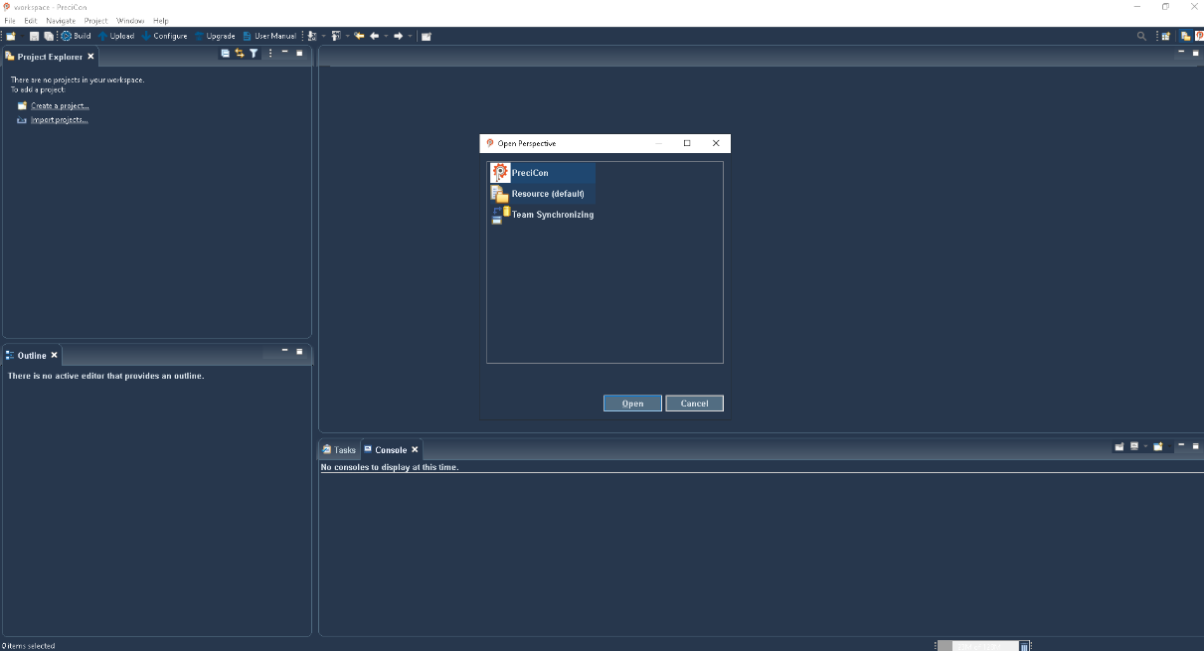

Figure 3 PreciCon tool

# PreciCon Navigator

The left part of the view hosts the Project Navigator, where all the PreciCon projects created by users are visible. Users can open or close projects, create new ones, and delete unnecessary ones.

# New Project Creation

* To create a new project, Right click on the right click on the PreciCon Navigator (in PreciCon Perspective) or Project Explorer (in other perspective) and Click New > Project.
* In the new project wizard, select a “Precicon Project” wizard and click the next button to create a new project.

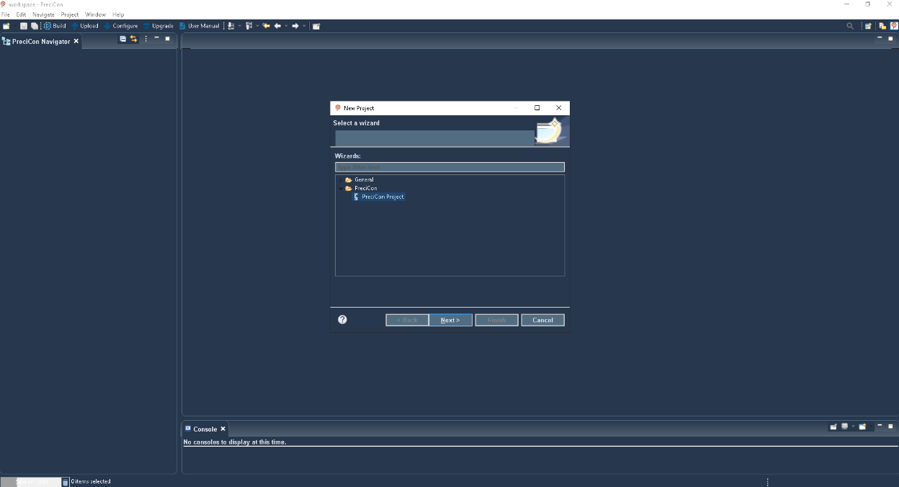

Figure 4 PreciCon project wizard

* Enter the project name and project description in this wizard and click the “Finish” button.
* The new project has been created.

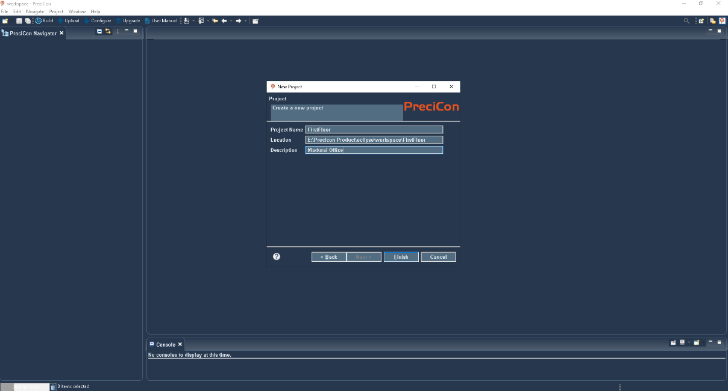

Figure 5 PreciCon project creation

* In this project, there are "devices" and "output" folders and a "precicon.pcp" file.
* In the "precicon.pcp" file, it shows the project name, description, and release version.

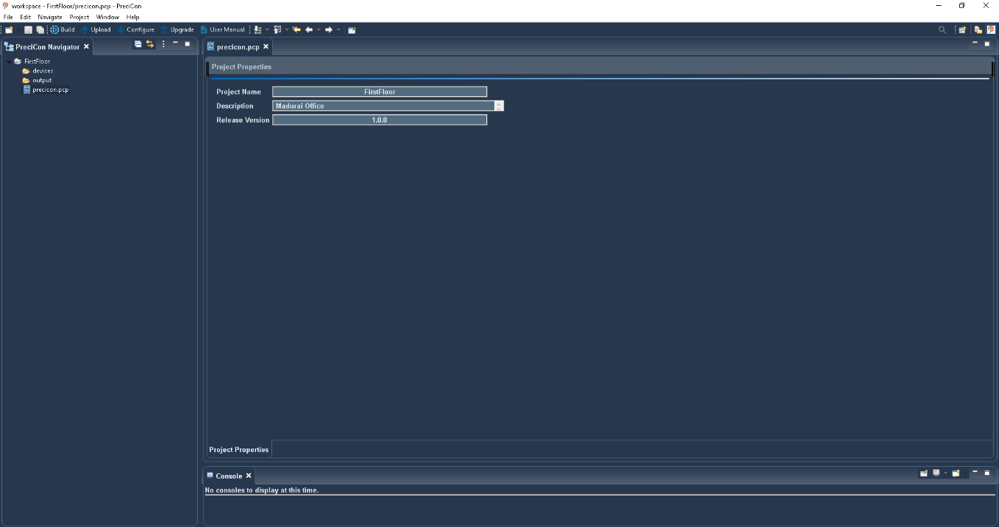

Figure 6 Project information page

# 4.1 New Device Creation

A project must have 1 gateway and support at most 32 devices.

Note:

* The device name must be unique and should be a maximum of 20 characters, consisting of alphabets, numbers, and underscores.
* The device label should be a maximum of 16 characters. Backslashes (\) and quotation marks (“) are not allowed in the label.

# 4.2 Creating a Gateway:

* To create a new Gateway, right-click the "devices" folder and select new->other.
* New device creation wizard will be opened.
* In this wizard, select "Precicon Device" and click the next button.

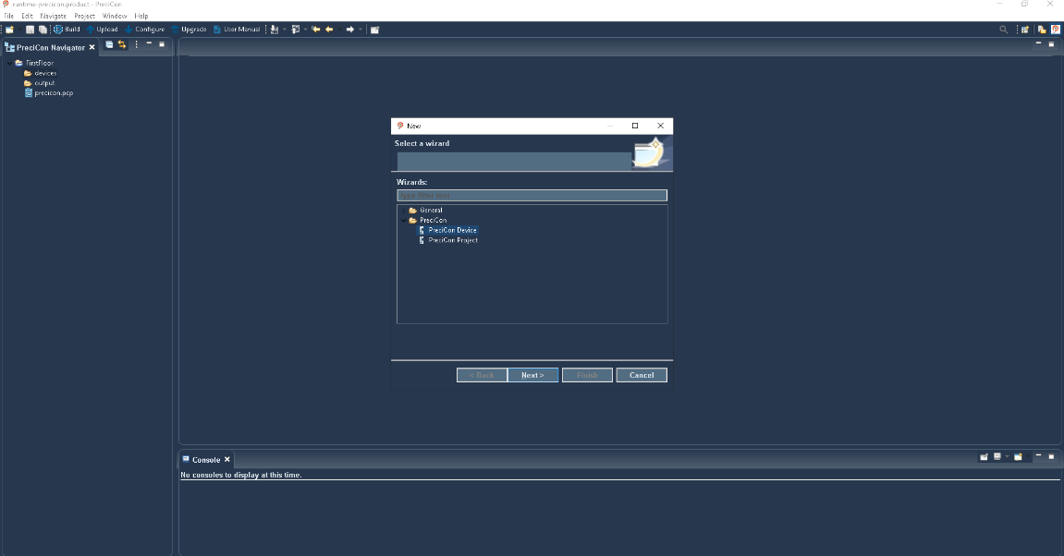

Figure 7 Device creation wizard

* Give this device file a name and click the next button, give the device a label, select vendor as Precisol Automation, Device type as Gateway, any preferred device variant.
* Click the “finish” button. Now new gateway device (.pcd) file will be created.

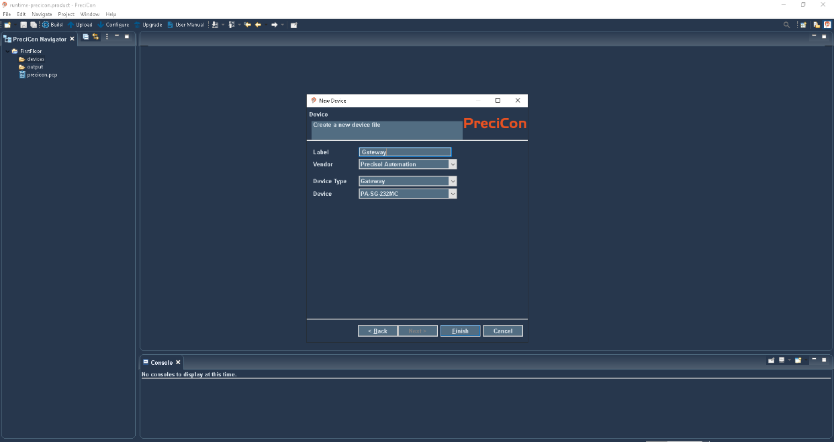

Figure 8 Vendor selection

Open the created gateway device file in Device editor, this editor has serial configuration, Cloud, Modbus master information, Data information, and device information tabs.

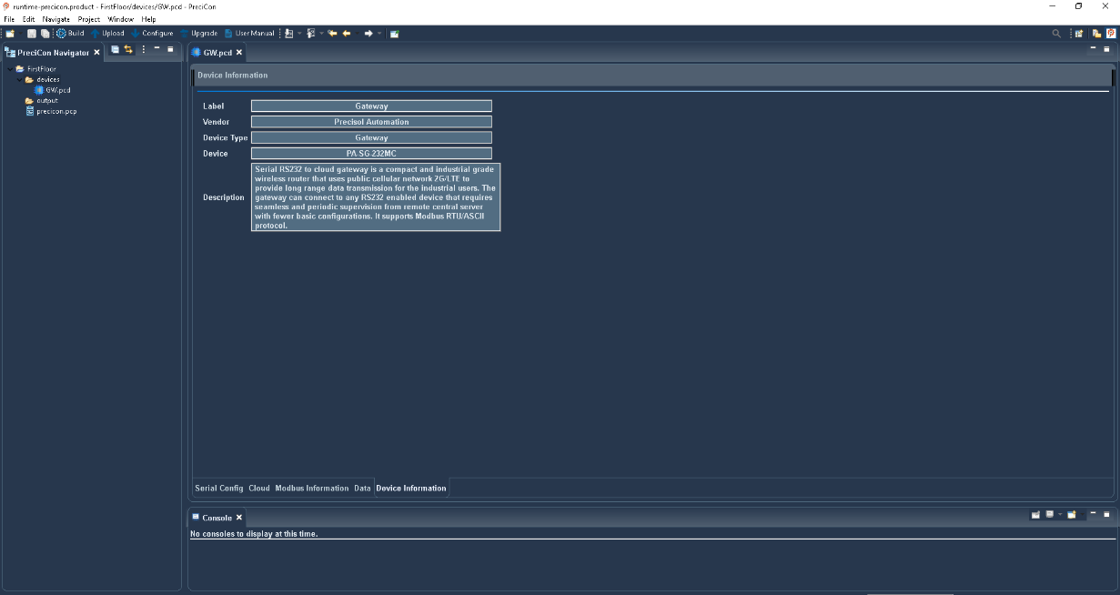

Figure 9 Gateway information page

# 4.3 Creating a Modbus Device:

* To create a new Modbus device, right-click the "devices" folder and select new->other.
* New device creation wizard will be opened. In this wizard, select "Precicon Device" and click the next button.
* Give this device file a name and click the next button, give the device a label, select vendor as "Rockwell Automation", Device type as Flowmeter, Energy meter any preferred device variant and click the “finish” button.
* Now new Modbus device (.pcd) file will be created.
* Open the created Modbus device file in Device editor, this editor has Modbus slave information, data information, and device information tabs.

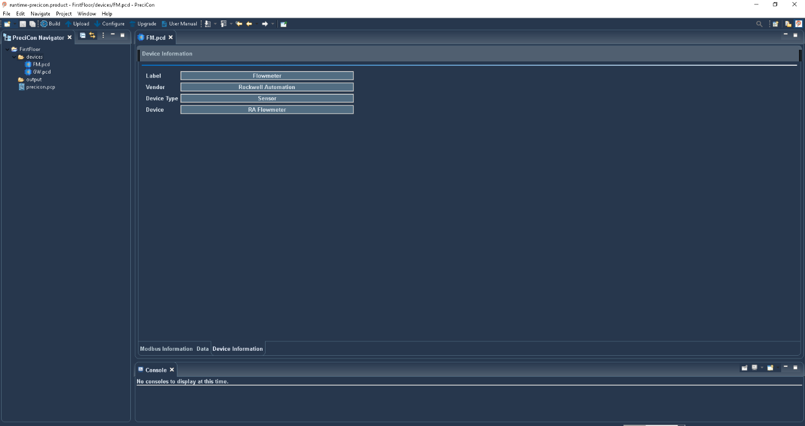

Figure 10 Modbus device information page

# Data Configuration

In the data information table of the Modbus device file, there are default data values that are uneditable and undeletable. Additionally, new data settings will be configured, which include the data name, type, and unit.

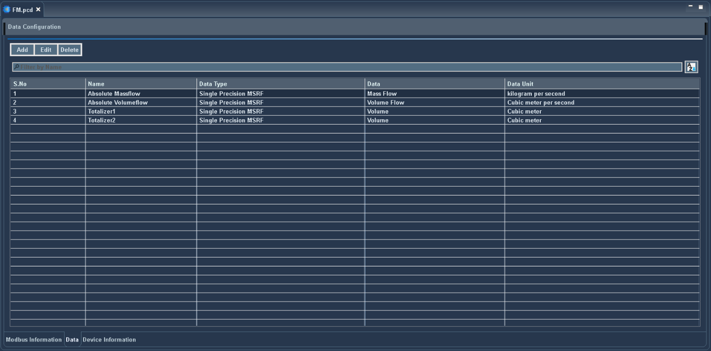

Figure 11 Data configuration page

## 6.1 New Data Settings Creation

In the data information table, new data settings will be added by clicking the 'Add' button, and existing settings can be edited or deleted using the 'Edit' and 'Delete' buttons.

The fields to be entered are:

* **Name**: User identifiable string that can be separated by space.
* **Data Type:** Size of memory to be allocated for the data.

**[** Some of the data storage types supported are captured below in the table]

|  |  |  |
| --- | --- | --- |
| Storage Type | Description | Modbus Register Occupied Size |
| Unsigned Int 8 | Unsigned value occupying 8 bits within range 0 to 256 | 1 |
| Signed Int 8 | Signed value occupying 8 bits within range -128 to 127 | 1 |
| Unsigned Int 16 | Unsigned value occupying 16 bits within range 0 to 65535 | 1 |
| Signed Int 16 | Signed value occupying 16 bits within range -32,768 to 32,767 | 1 |
| Unsigned Int 32 Types | Unsigned value occupying 32 bits within range 0 to 4,294,967,295 | 2 |
| Signed Int 32 Types | Signed value occupying 32 bits within range -2,147,483,648 to 2,147,483,647 | 2 |
| Single Precision Types | Value occupying 4 bits within range 3.4E +/- 38 | 2 |
| Double Precision Types | Value occupying 8 bits within range 1.7E +/- 308 | 4 |
| String | To store string values | 4 |

* **Data**: Indicates the physical type of the data such as Mass Flow, Volume Flow etc.,
* **Unit:** Indicates the unit of the selected data, according to the selected data type.

If custom type is selected the text box is shown in that textbox user can enter a custom unit.

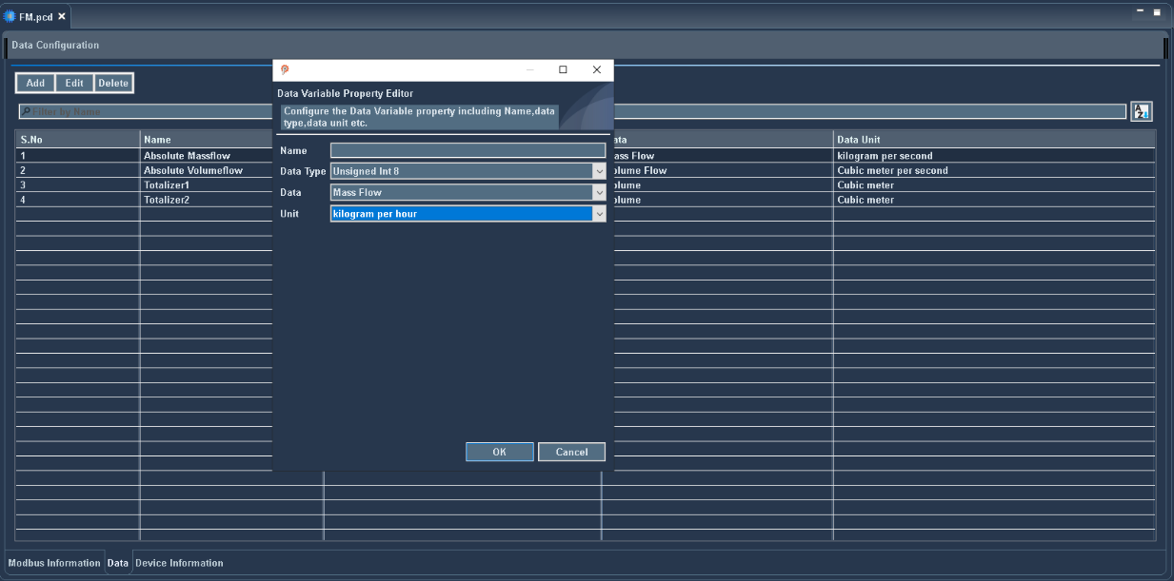

Figure 12 Data settings configuration popup

Note:

* After creating new data, saving the file is necessary to reflect the newly created data in the Modbus information table

## 6.2 Modbus Configuration

In the Modbus information table, there are default Modbus values that are uneditable and undeletable. Also, new Modbus settings will be configured, which include register type, Modbus register address, and data.

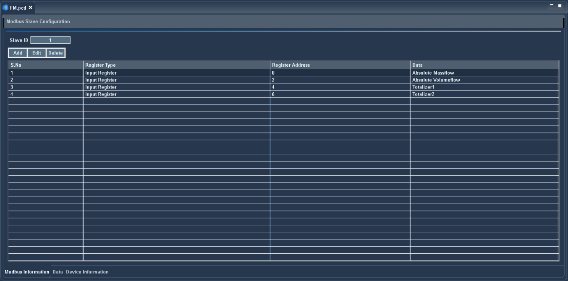

Figure 13 Modbus slave configuration page

## 6.3 New Modbus Settings Creation

In the Modbus information table, new Modbus settings will be added by clicking the 'Add' button, and existing settings can be edited or deleted using the 'Edit' and 'Delete' buttons.

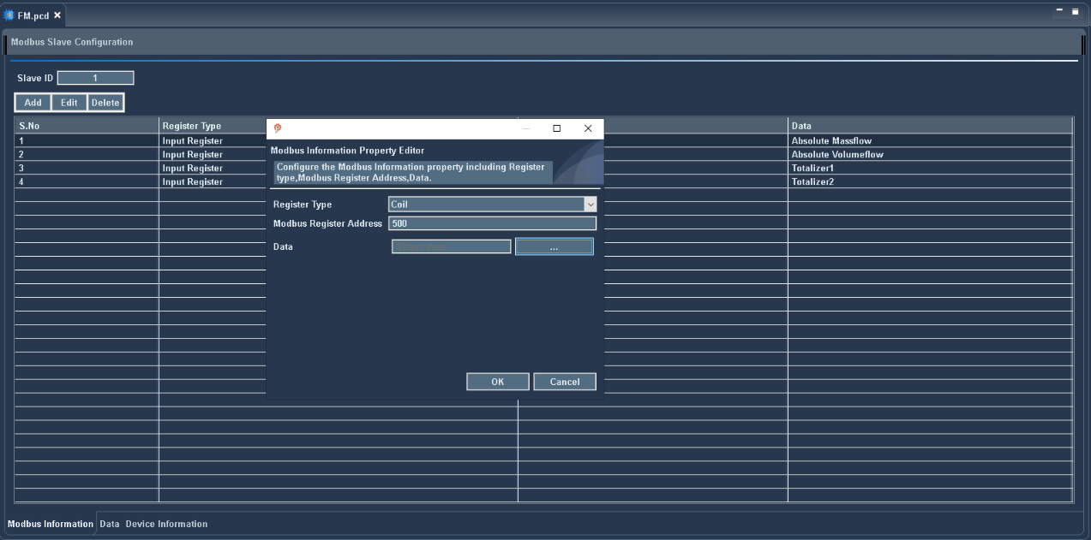

Figure 14 Modbus settings creation popup

# Serial Configuration

Serial configuration in the gateway to configure protocol, baud rate, data bits, parity, and stop bits. Flow control is also configured if the protocol is an RS-232 gateway.

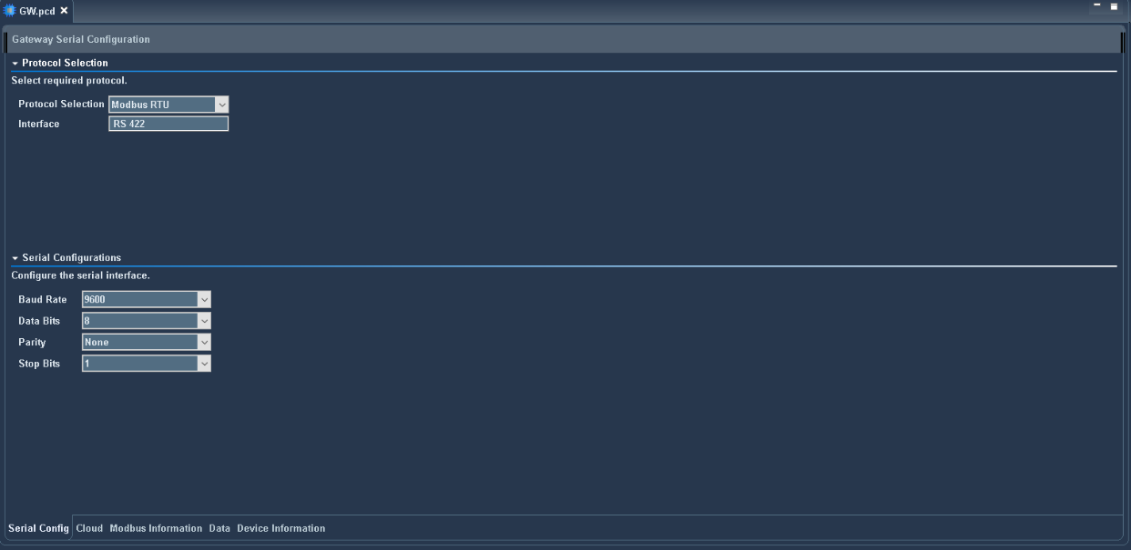

Figure 15 Serial configuration page

* **Modbus Protocol:** Supported Modbus protocols comprise RTU and ASCII.
* **Serial Baud Rates:** The available Modbus baud rates include 110, 300, 600, 1200, 2400, 4800, 9600, 14400, 19200, 38400, 57600, 115200, 230400, 460800, and 921600 bps.
* **Data Bits:**
* For the RTU protocol, only 8 data bits are supported.
* For the ASCII protocol, both 7 and 8 data bits are supported.
* **Parity:** Supported Modbus parity options are None, Odd, and Even.
* **Stop Bits:** Supported Modbus stop bits include One and Two.
* **Flow Control:**
* Flow control is specifically supported for RS232.
* Supported Flow control options are Off, XON/XOFF, and RTS/CTS.

## 7.1 Cloud Configuration

On the cloud page, the Protocol, SSL, URL, Access Token, GPS transmit, GPS interval, start time, and time interval are configured.

**Protocol:** Supported protocols comprise HTTP, MQTT

## 7.1.1 MQTT Protocol Properties

Quality of Service, username, and password are configured in the MQTT protocol. It is a key feature that ensures the reliability and delivery assurance of messages between the client and the broker. There are three levels of QoS in MQTT, each providing a different level of guarantee.

* **QoS 0 - At most once:** The message is delivered at most once, and no acknowledgment is required.
* **QoS 1 - At least once: The message is delivered at least once, but it may be delivered multiple times if acknowledgments are lost. The sender stores the message until it receives an acknowledgment from the receiver.**
* **QoS 2 - Exactly once:** The message is guaranteed to be delivered exactly once. This level involves a four-step handshake between the sender and receiver to ensure that the message is neither lost nor duplicated.

Username and password are crucial for authenticating clients, controlling access to resources, and enhancing overall security in an MQTT-based communication system

## 7.1.2 HTTP Protocol Properties

Content type and custom header are configured in the HTTP protocol. It enables proper handling and rendering by the recipient, and ensuring smooth interoperability between different components in web communication

The available SSL options are No SSL, SSL with no authentication, SSL with server authentication.

* No SSL: This option is generally used in trusted or controlled environments where security is not a concern, or during development/testing phases
* SSL with No Authentication: It can be used in internal networks or systems where you trust the endpoints but want to prevent data interception
* SSL with Server Authentication: The communication is encrypted, and the server presents a digital certificate to the client to authenticate its identity. The client verifies the server’s certificate against a trusted Certificate Authority (CA) or a predefined list of trusted certificates

## 7.2 Access Token

The access token is a unique identifier for the gateway that allows the Precicon tool to connect to the cloud for uploading configurations.

## 7.3 GPS Interval

If GPS transmit is enabled, then GPS interval text box will become visible. In this text box, the user can enter a time interval in seconds

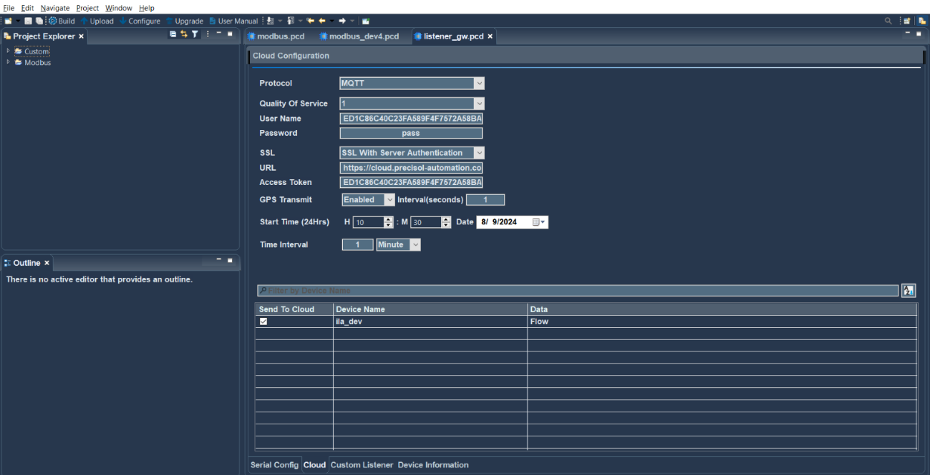

Figure 16 Cloud configuration page

Note: When configuring data transmission intervals for sending data to the cloud, certain limitations apply to ensure optimal performance and resource utilization. These limitations vary depending on the time unit chosen for the interval.

Below are the limitations outlined for each time unit:

* Seconds: 1 to 60 seconds
* Minutes: 1 to 60 minutes
* Hours: 1 to 24 hours
* Days: 1 to 45 days
* Months: 1 month

## 7.4 Polling Interval

* The polling interval is the period between consecutive checks or requests for data updates from connected devices.
* This option is only available for Modbus RTU and Modbus ASCII protocols.
* If Polling interval is enabled, then the Polling interval text box will become visible. In this text box, the user can enter a time interval in milliseconds.

## 7.5 Cloud Data Send Selection

To send data to the cloud or device, the URL, access token, start time, time interval, and selection of the data that is sent to the cloud must be configured.



Figure 17 Cloud configuration

In the cloud data details table, it shows all the devices with their configured data for that project. and select the data to which you want to send a cloud

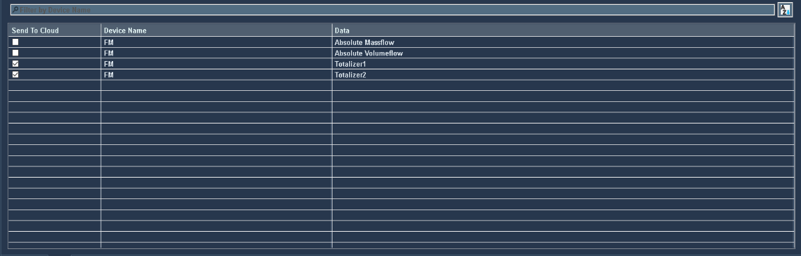

Figure 18 Cloud send data selection table

# WinUSB Installation

Follow these steps to install the WinUSB Driver for Gateway Device:

* + Connect 12V DC power supply provided with the package. If not opted, kindly use market available 12V/1.5A DC power adapter.
  + Connect the Gateway via Mini USB cable to the PC for before device configuration
  + download the ‘libusb-win32-devel-filter-1.2.7.3.exe’ driver.
  + Double-click the ‘libusb-win32-devel-filter-1.2.7.3.exe’

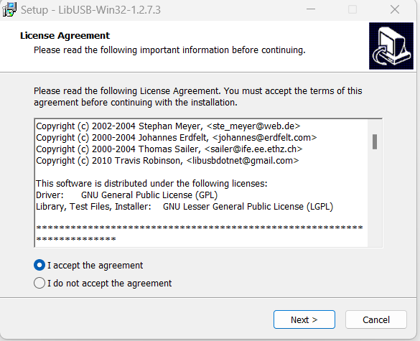

Figure 19 Setup LIBUSB_Win32

* + Followed with the running of the .exe file, A dialog box will appear
  + Read the policies then, select ‘I accept the agreement’ and ‘click Next’
  + Click ‘Next’ again in the dialogue box

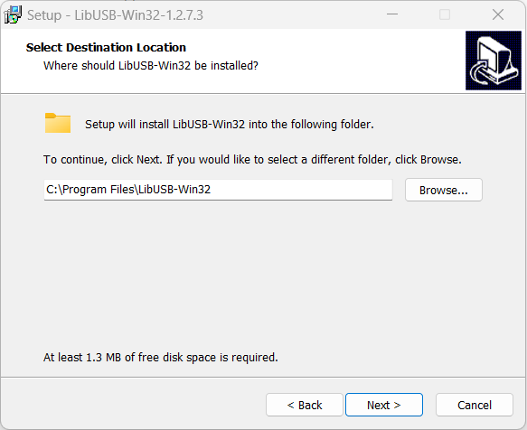

Figure 20 Setup LIBUSB_Win32_1

* + Choose the installation path and click ‘Next’

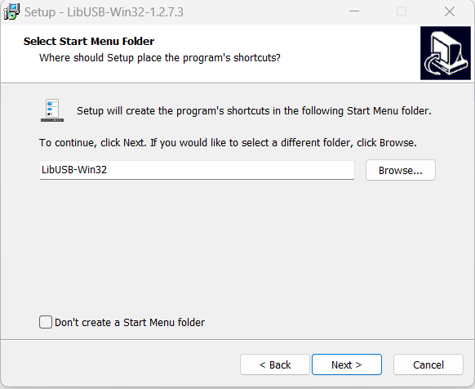

Figure 21 Setup LIBUSB_Win32_2

* + Click ‘Next’ and then ‘Install’

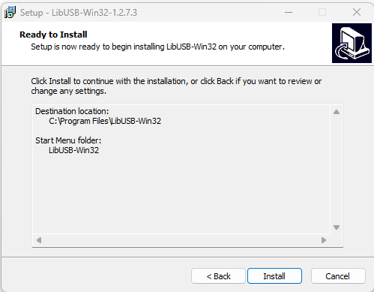

Figure 22 Setup LIBUSB_Win32_3

* + Click the ‘Finish’ button to complete the installation process of the LibUSB Win32

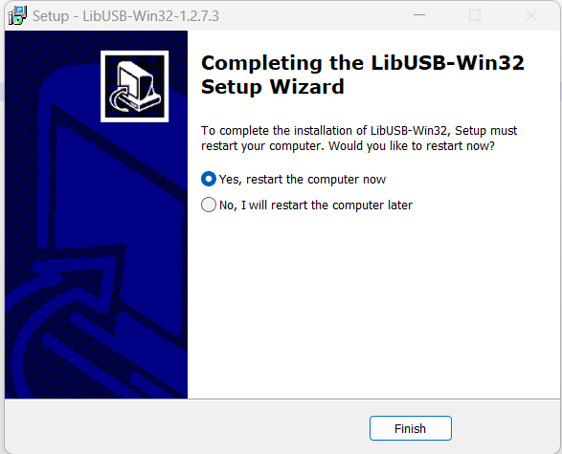

Figure 23 Setup LIBUSB_Win32_4

* The LibUSB Win32 has been installed now. Proceed by inserting the GW Device option.
* In Device manager check whether the device is shown in the list.

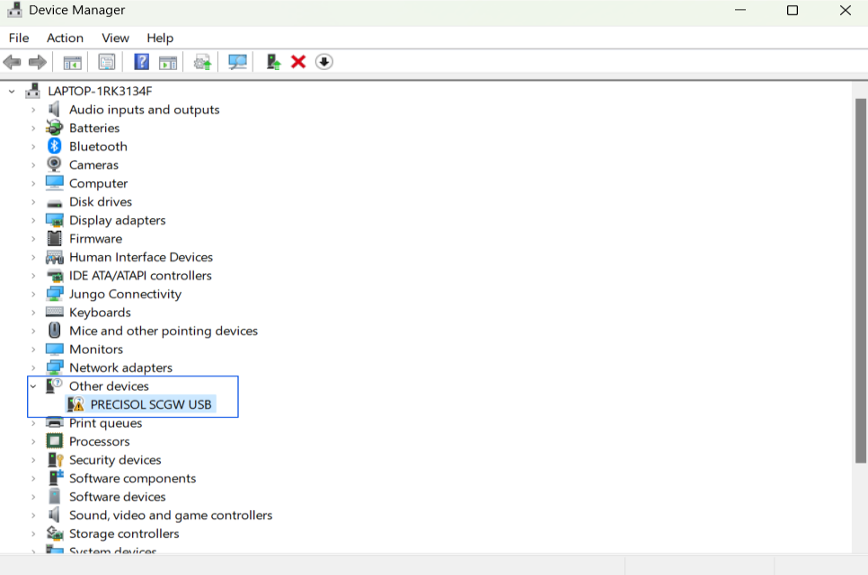

Figure 24 Device Manager

* Choose "Install a device filter" and proceed by clicking 'Next'.
* If this option does not appear an automatically, click 'Start' and navigate to the LibUSB-WIN32 folder to open the Filter Wizard.

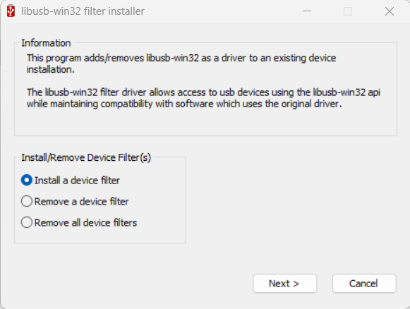

Figure 25 LIBUSB_Win32_5

* Choose 'vid:4701 pid:0291 rev:0200' from the Device selection menu, then proceed by clicking on the Install button.

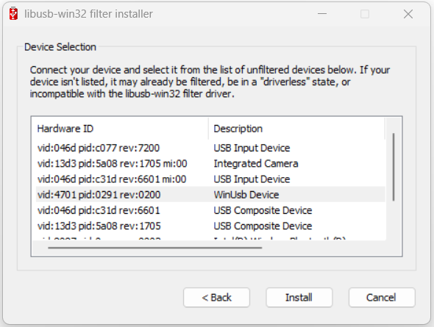

Figure 26 LIBUSB_Win32_6

* Once the Filter is applied successfully, close the dialog.

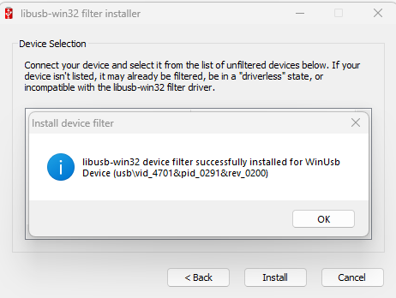

Figure 27 LIBUSB_Win32_7

* After a successful device update, "PRESICOL SEGW USB" will be listed under Universal Serial Bus devices.

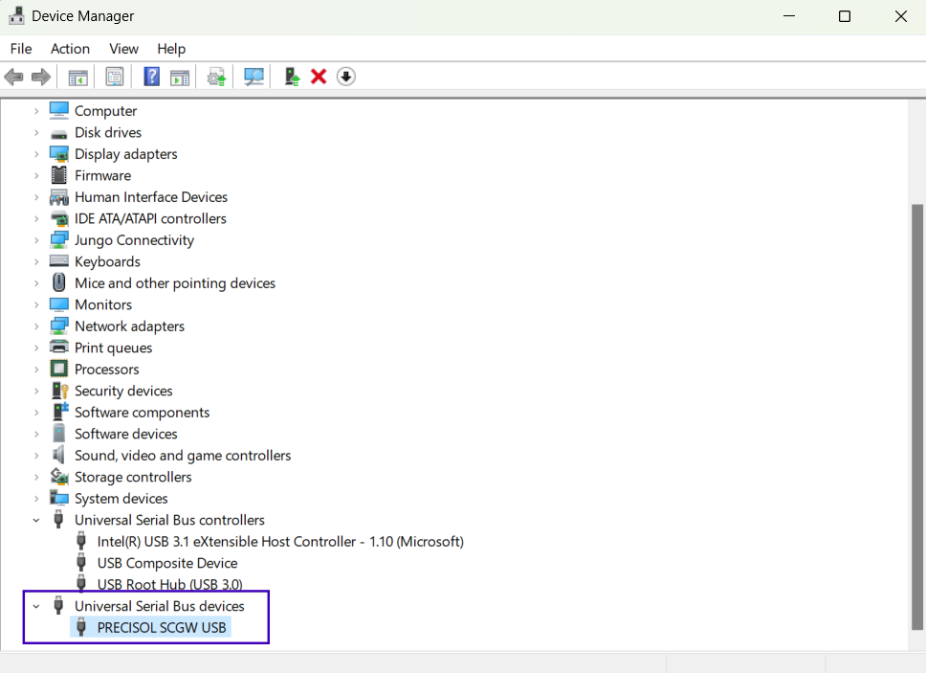

Figure 28 Device Manager_1

# Configure a Device

To initiate data configuration on the device, it is important to have both USB cable connectivity and power supply. Select the project to which you want to configure and simply click the "Configure" button, then designated data will be transmitted to the device.

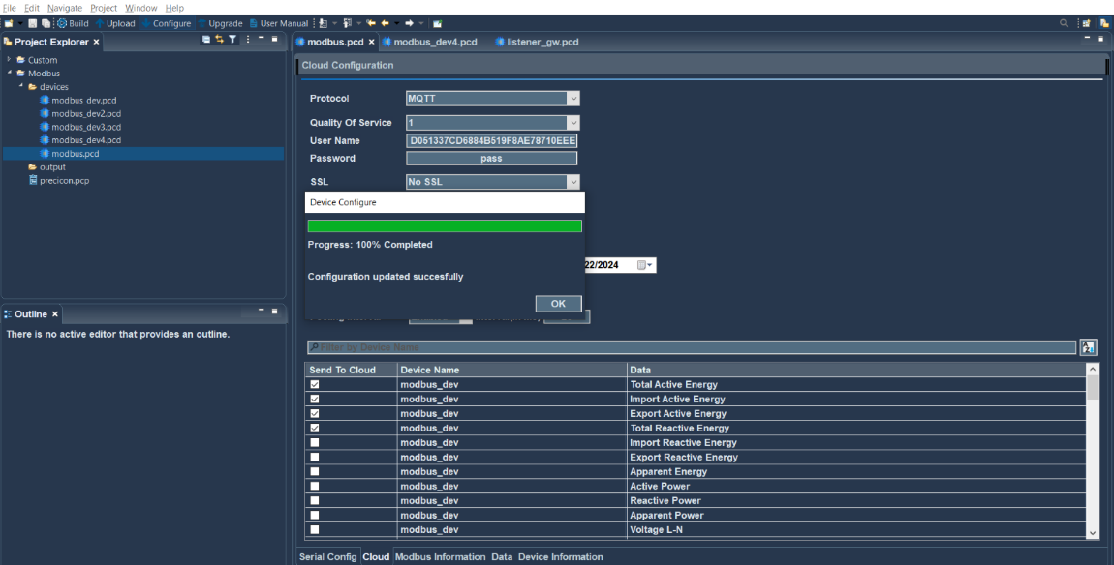

Figure 29 Configure data on the device

The device contains three LEDs to convey various indications. The details of these indications are as follows:

|  |  |  |
| --- | --- | --- |
| LED | Condition | Status |
| Power LED (Red) | On | Device Power on |
| Mod bus LED (Green) | Fast blink | When Modbus client is stopped or deactivated. |
| Slow blink | When Modbus client is activated and running. |
| Solid state | During firmware upgrade process |
| Cloud Communication LED (Green) | Fast blink | During communication between gateway and cloud. |
| Slow blink | When network is registered, and internet is available |
| Solid state | During USB communication |

# Upload to Cloud

Network connectivity is essential for uploading a configuration to the cloud. To upload data to the cloud, Select the project to which you want to upload and click the "Upload" button, and the configured data will be sent to the cloud.

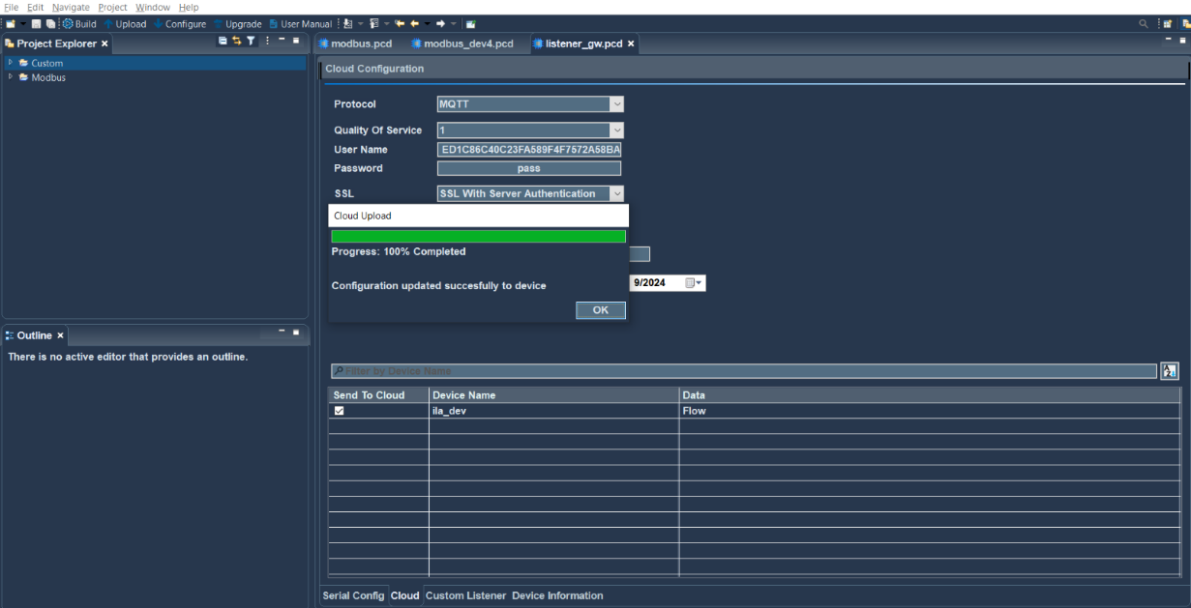

Figure 30 Upload data to cloud

PreciCloud is a readily available cloud dashboard from Precisol Automation for viewing the acquired data graphically using multiple widgets from anywhere at any time. Following are the requirements to setup the PreciCloud dashboard,

* + - A PC with network connectivity
    - Credential provided during purchase of the cloud gateway
    - For more details, please refer the document “PreciCloud User manual”

# Firmware Update

To start a firmware update for gateway device, ensure both USB cable connectivity and power supply are available. Simply click the "Upgrade" button. This will trigger a popup window to appear.

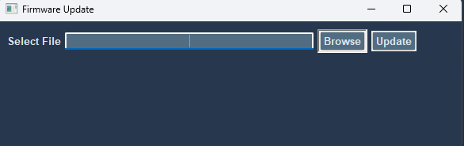

Figure 31 Firmware file selection popup

In this window, choose the ".bin" file by clicking the browse button, then proceed by clicking the “update” button to begin the firmware update process. After completing this process, the gateway device is updated to the new version

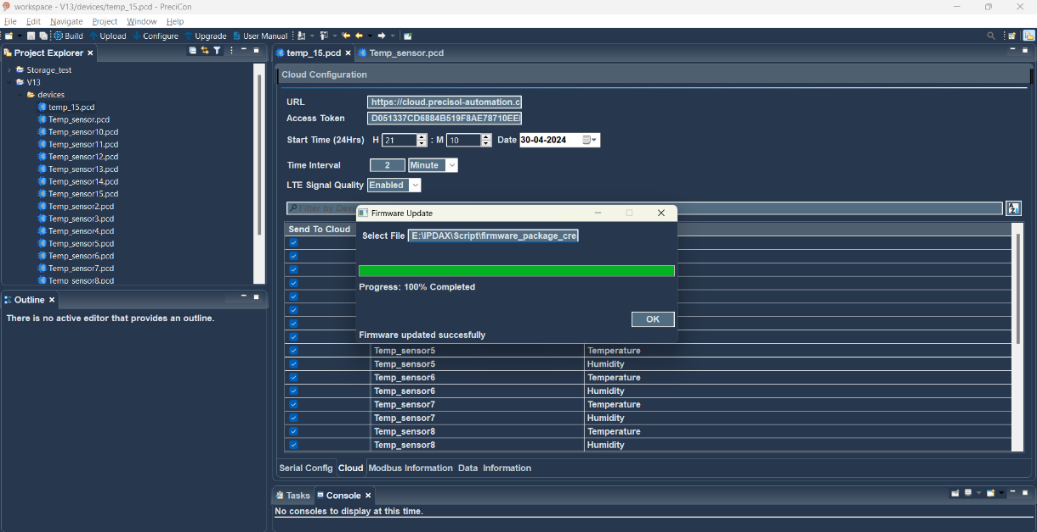

Figure 32 Updating the firmware of a device