

Sense for Machines



PreciCon Tool

*Quick Start Guide*

*Version 1.0*

Table of Contents

1. Introduction 3

2. Prerequisites 3

3. Launching PreciCon 3

4. Create a New Project 4

5. USB Driver Installation 5

6. Cloud Upload 5

7. Configure a device 6

8. Firmware Updates 6

Table of Figures

Figure 1 PreciCon Launching Package 4

Figure 2 PreciCon Launching Window 4

Figure 3 New Project Creation Window 5

Figure 4 Device Manager 6

Figure 5 Cloud Upload Window 6

Figure 6 Device Configuration 7

Figure 7 Firmware Update 7

# Introduction

PreciCon is a powerful Eclipse based Configuration tool from Precisol Automation to configure the Serial interface, Modbus, Telemetry data and Cloud Communication of the Gateway and end devices from the premises via USB or from Remote by uploading the configuration to PreciCloud.

# Prerequisites

Following are the system requirements to setup the PreciCon tool,

* 64-bit PC with at least 4GB RAM and 1 GB free hard disk space.
* 64-bit Java 11 or newer JRE/JDK is required. Latest releases are preferred Currently, Java versions up to 17.0 are compatible with PreciCon.

# Launching PreciCon

To begin with, the PreciCon tool is provided as a compressed archive – “precicon_xxx.zip” file, whereas xxx is the version number of the PreciCon. Extract the same with your preferred tool. For example, when using WinRAR, right click the precicon.zip file and select Extract to PreciCon as shown below image

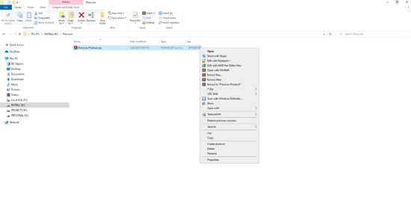

Figure 1 PreciCon Launching Package

* After unzipping, click an eclipse folder and double-click the precicon.exe file to run precicon.
* Designate a workspace location for PreciCon to store the project. By default, it resides where the precicon.exe file is located.
* Also, the user can select any folder of their choice.

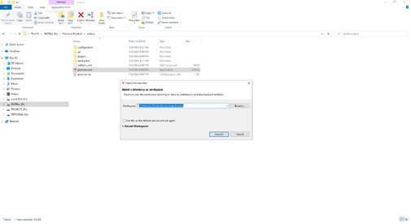

Figure 2 PreciCon Launching Window

* After launching, the PreciCon tool will ask for a workspace location.
* Select a suitable folder and hit “OK” button to proceed further.

# Create a New Project

The following section will capture the steps to create a new project:

1. Go to **File** > **New Project**.
2. Follow the wizard by providing project details such as project name and device information.

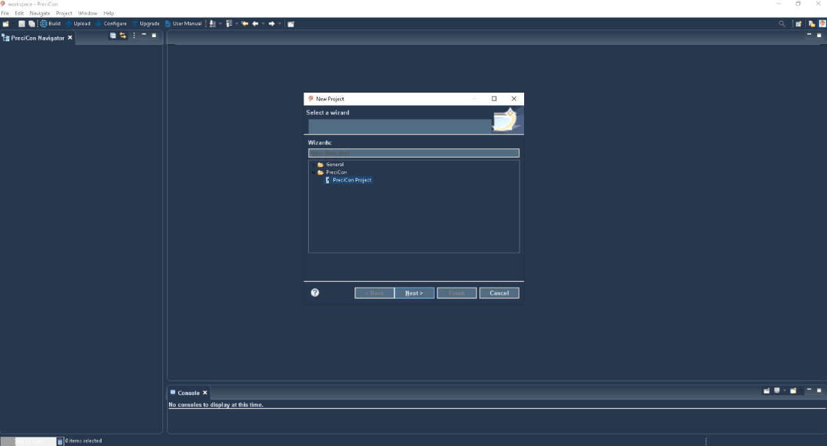

Figure 3 New Project Creation Window

# USB Driver Installation

Follow the below steps to install the WinUSB Driver for Gateway Device:

* Connect 12V DC power supply provided with the package. If not opted, kindly use market available 12V/1.5A DC power adapter.
* Connect the Gateway via Mini USB cable to the PC for before device configuration
* download the ‘libusb-win32-devel-filter-1.2.7.3.exe’ driver and choose **libusb-win32** from the driver list and click **Install Driver**.
* After the driver is installed, you can confirm it in **Device Manager** under **libusb-win32 devices**

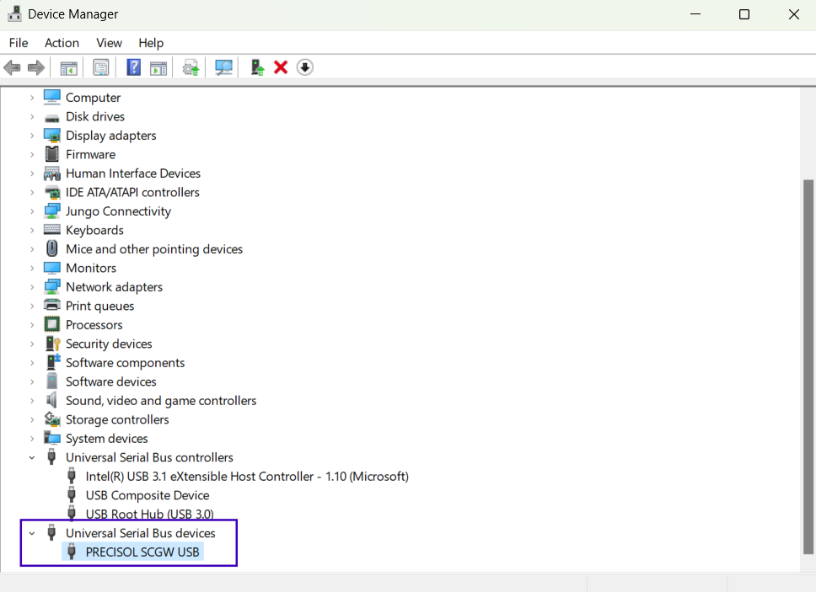

Figure 4 Device Manager

# Cloud Upload

Once all settings and configurations are done, user can upload the data to the cloud through the Upload to Cloud option in the UI interface.

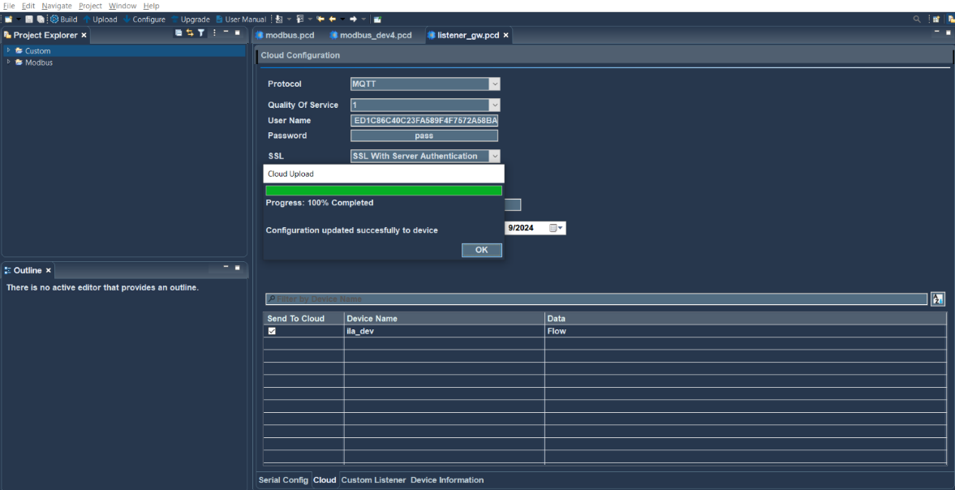

Figure 5 Cloud Upload Window

# Configure a device

To initiate data configuration on the device, it is important to have both USB cable connectivity and power supply. Select the project to which you want to configure and simply click the "Configure" button, then designated data will be transmitted to the device.

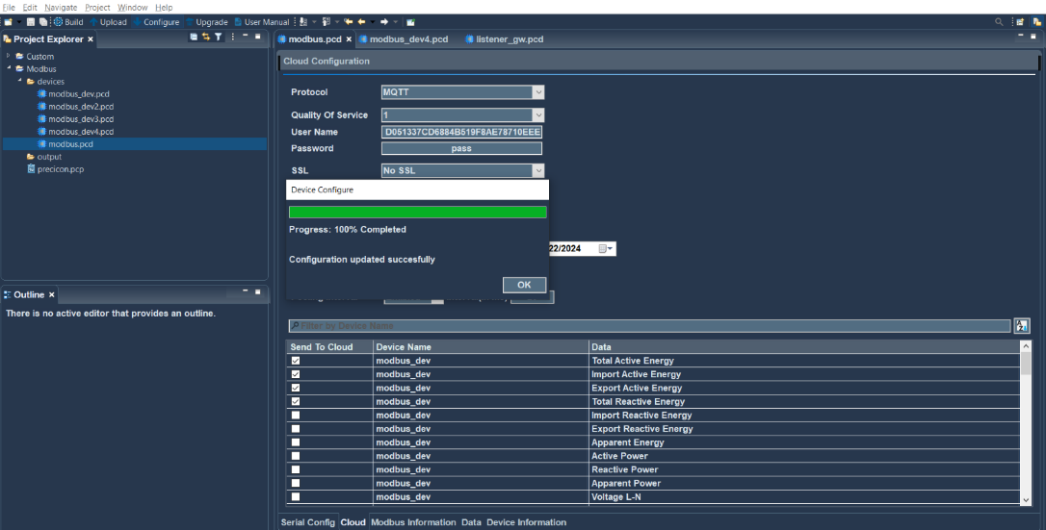

Figure 6 Device Configuration

# Firmware Updates

To start a new firmware update for gateway device, ensure both USB cable connectivity and power supply are available. Simply click the "Upgrade" button. This will trigger a popup window to appear.

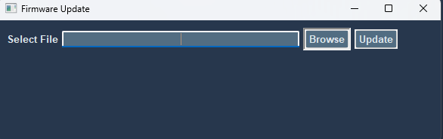

Figure 7 Firmware Update

*For further information, refer to the user manual of the PreciCon.*