**``````````````````````````````````````````**



**.**

Sense for Machines

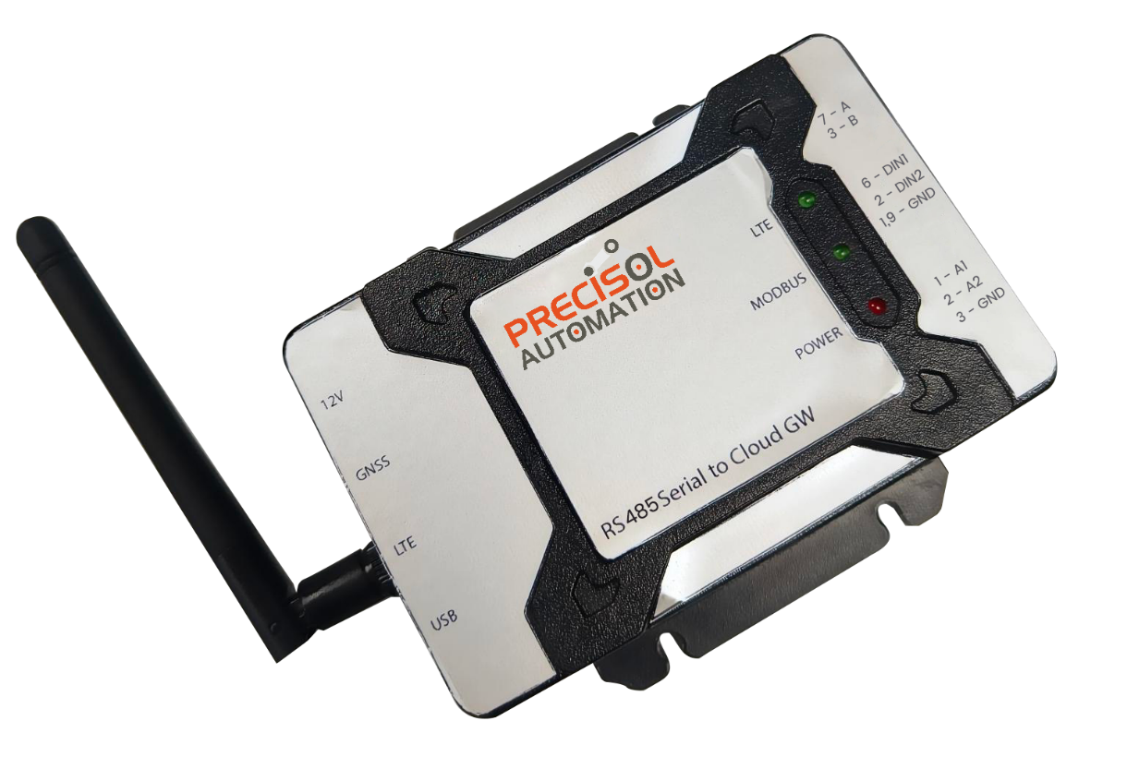

RS485 Serial to Cloud Gateway

*User Manual*

*Version 1.0*

Table of Contents

1 Introduction 5

1.1 Device Specification 5

1.2 Product Deliverables 7

2 Device Operation 8

3 Tool Setup Requirements 9

3.1 USB Driver Installation steps 9

3.2 PreciCon – Custom Configurator Tool 13

3.3 PreciCloud – Custom Cloud Dashboard 14

4 Device Connection 14

4.1 Power Supply 14

4.2 Antenna 15

4.3 RS485 Serial connection 15

4.4 Analog Inputs 15

4.5 Digital Inputs 15

5 Device Configuration 16

5.1 PreciCon 16

5.1.1 Project Creation 16

5.1.2 Device Creation 17

5.1.3 Serial Configuration 18

5.1.4 Modbus Configuration 19

5.1.5 Produce & Consume Configuration 21

5.1.6 Cloud Upload Configuration 22

5.1.7 USB Device Configuration 22

5.1.8 Remote Device Configuration 22

5.1.8.1 Configuration Status 23

5.1.9 Modbus Write Configuration 23

5.2 PreciCloud 23

6 Firmware Upgrade Process 25

6.1 FOTA via PreciCloud 25

6.2 Upgrade through USB 26

6.3 Firmware Upgrade & Connection Status 26

7 LED Indication 27

8 FAQ 27

Table of Figures

Figure 1: Device Operating Procedure 8

Figure 2: USB driver update – Uninitialized USB 9

Figure 3: USB driver update – Update uninitialized Driver 10

Figure 4: USB driver update – Search driver 10

Figure 5: USB driver update – Browse driver 11

Figure 6: USB driver update – Device type selection 11

Figure 7: USB driver update – Select WinUsb Device driver 12

Figure 8: USB driver update – Successful Update 12

Figure 9: USB driver update – Updated USB device 13

Figure 10: Serial to cloud Gateway – Hardware connections 14

Figure 11: New Project Creation Window 16

Figure 12: Device Creation Window 17

Figure 13: Modbus - Serial Configuration Window 18

Figure 14: Produce & Consume - Serial Configuration Window 18

Figure 15: Modbus device structure Details 19

Figure 16: Data Information Table 20

Figure 17: Modbus Information Table 20

Figure 18: Produce & Consume Configuration 21

Figure 19: Cloud Upload Configuration Window 22

Figure 20: Dashboard with Gateway Details 24

Figure 21: Dashboard with Modbus Device Details 24

Figure 22: Dashboard with Produce & Consume Device Details 25

# Introduction

This manual includes details on the features, prerequisites, device connection, setup and operating process for RS485 serial to Cloud Gateway.

## Device Specification

RS485 serial to cloud gateway is a robust and compact industrial-grade device, ideal for acquiring data from RS485 enabled devices at configurable intervals and uploading it to the cloud for remote monitoring. Following table describes the technical specification of the gateway,

|  |  |
| --- | --- |
| Function | RS485 Serial to Cloud Gateway |
| Power Supply | 12V DC |
| Power consumption | 1.5A Max @12V |
| PC interface | USB Mini B connector  USB device communication for configuration using PreciCon tool  External interface via DB-9 connector |
| RS485 Serial Interface | External interface via pluggable terminal connector  Data bits: 7,8 bits  Baud Rate: 300, 600, 1200, 2400, 4800, 9600, 14400, 19200, 38400, 57600, 115200, 128000, 256000, bps  Stop bits: 1, 2 bits  Parity: None, Odd and Even |
| Environmental | Dimension: 105 mm X 68 mm X 31.5 mm (W/O flanges)  Weight: 138 gm  ABS plastic (IP40)  Operating Temperature: -40 to 85 Degree Celsius |
| Data storage Capability | Non-Removable microSD card  8 to 32GByte |
| Status Indication | LED 1 for Cloud network communication status  LED 2 for Serial communication status  LED 3 for Power status |
| Analog input | |
| Number of channels | 2 |
| Range | Current Input – 4mA to 20mA |
| Resolution | 16-bit |
| Input impedance | 120 ohms |
| Digital Input | |
| Number of channels | 2 |
| Input Switching Threshold | High = Greater than 3V or 1.5V (optional, to be mentioned during ordering)  Low = Less than 3V or 1.5V (optional, to be mentioned during ordering) |
| Voltage input limit | 30V Max |
| 4G LTE | |
| LTE Category | LTE CAT 1  Support for global coverage including Europe, US, Asia-Pacific, etc (optional, to be mentioned during ordering) |
| Bands | LTE-FDD: B1/3/5/8  LTE-TDD: B34/38/39/40/41  GSM: B3/8 |
| Antenna | SMA connector for external finger type or expandable antenna |
| SIM interface | Inbuilt non-removable Micro SIM card |
| Cloud Data Transfer | |
| Data Transfer | * Upload to PreciCloud at configurable interval from 10 seconds to 1 month. * Data will be stored in inbuilt microSD card when cloud connectivity is disconnected. |
| Time Stamp | * Inbuilt battery backed RTC with year, month, date, weekday, hours, minutes, seconds and milliseconds data. * RTC can be auto synced via LTE network. |
| UID | * Each device has a globally unique ID ensuring secured cloud registration. |
| Diagnostics | * Periodic heartbeat to cloud for connection supervision. |

## Product Deliverables

Standard package includes,

* RS485 Serial to Cloud Gateway
* 1x LTE antenna (Rubber Duck Antenna)
* DB-9 connector for RS485 serial connection and Digital input (Optional)
* IP40 rated enclosure
* PreciCon – a device configuration tool
* PreciCloud – a cloud dashboard
* 12V DC power adapter (Optional)
* 1x GPS extendable wire antenna (Optional)
* Mini USB B to USB type A converter cable (Optional)
* 3-Pin mating connector for Analog input (Optional)
* Inbuilt non-removable Micro SIM card, 8 to 32GByte Micro SD card and CR1225 12mm RTC Coin cell battery (Optional)

# Device Operation

Following section shows the flow of operation from tool setup to data view in the cloud,

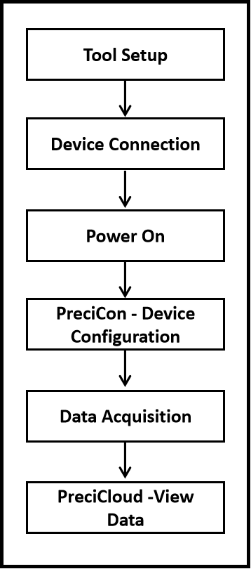

Figure 1: Device Operating Procedure

* Connect 12V power adapter to power input. Ensure power through power LED is on.
* Connect RS485 A and B signals to your slave device.
* Configure gateway’s serial settings, Modbus / Produce & consume parameters, cloud settings, etc in the PreciCon and initiate the data acquisition.
* View the live acquired data in PreciCloud dashboard.

# Tool Setup Requirements

This section covers the software setup requirements. Installation software and documentation are available at <https://precisol-automation.com/rs485-serial-to-cloud-gateway/> .

# USB Driver Installation steps

USB provides a dependable, standardized, and extensively supported interface for connecting devices, transferring data, and delivering power, making it essential for contemporary computing and electronics.

* Install the driver available in the package named as “**libusb-win32-devel-filter-1.2.7.3**”.
* Open the device management on your PC.
* Under the Other devices drop down setting, the "PRECISOL SEGW USB" device name will be visible and should be updated.

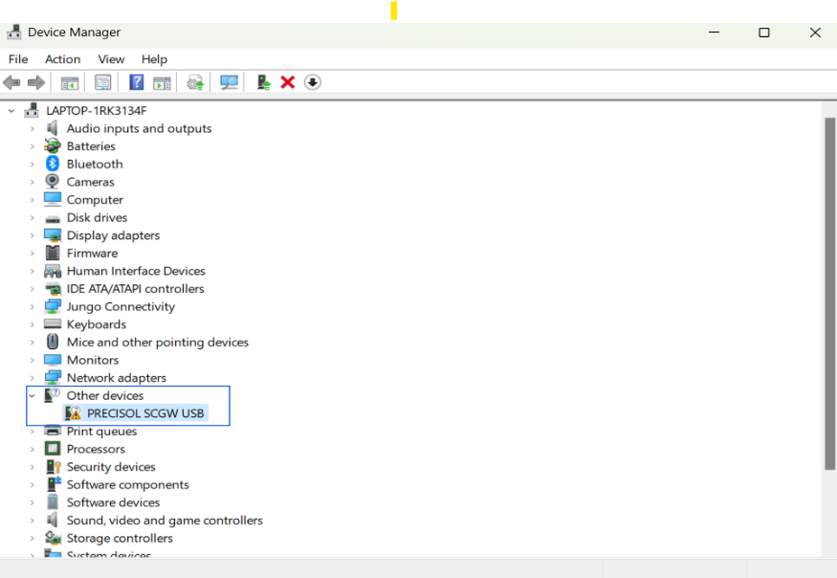

Figure 2: USB driver update – Uninitialized USB

* To update the "PRESICOL SEGW USB" device, select Update driver and follow the installation methods outlined in the figures below.

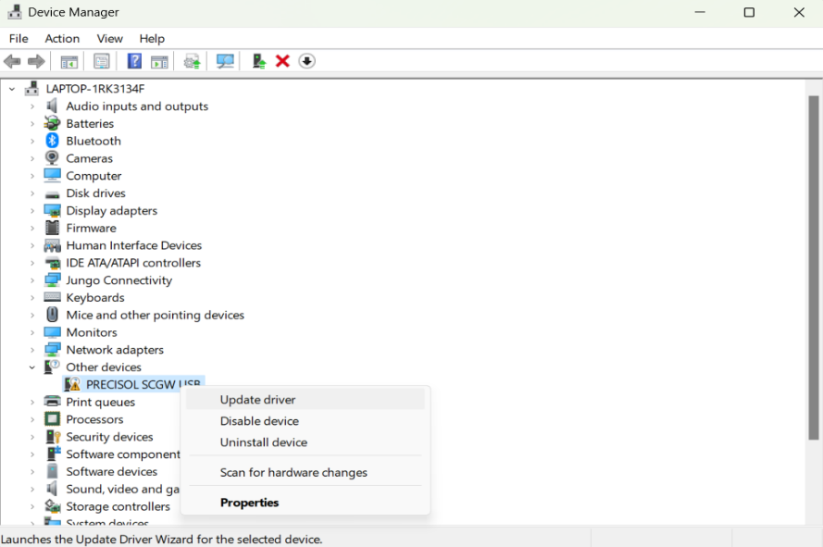

Figure 3: USB driver update – Update uninitialized Driver

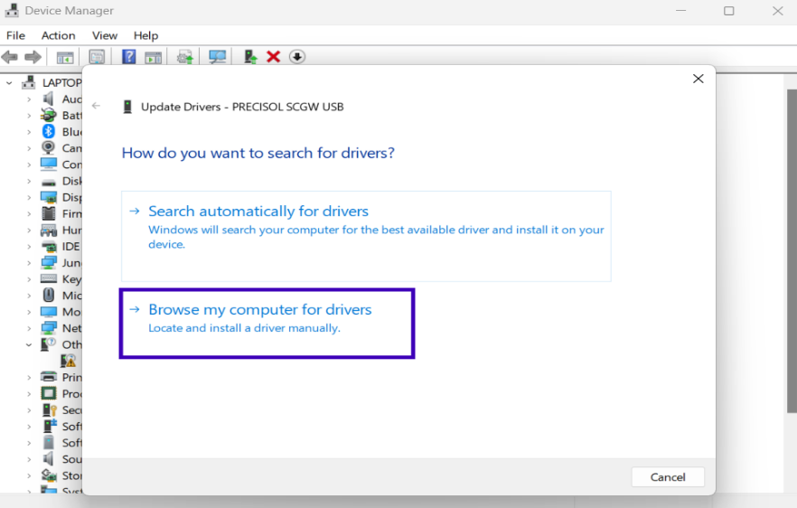

Figure 4: USB driver update – Search driver

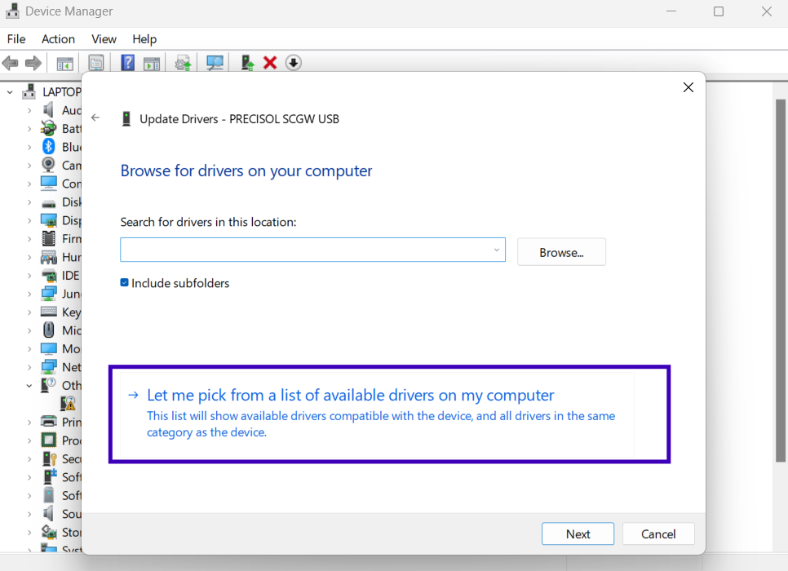

Figure 5: USB driver update – Browse driver

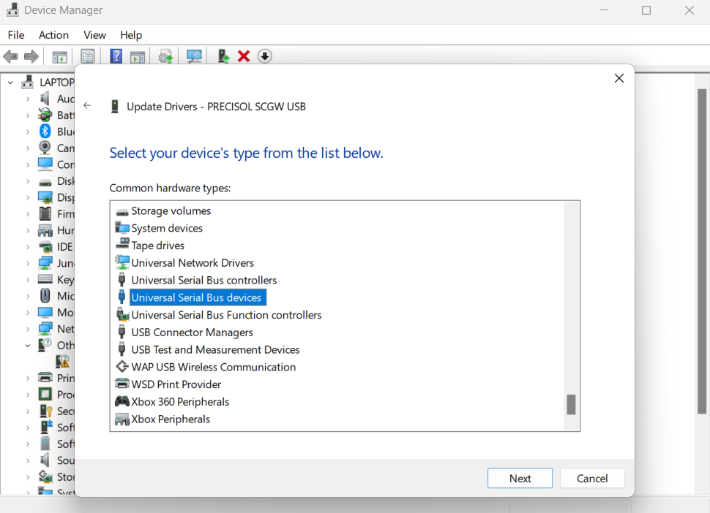

Figure 6: USB driver update – Device type selection

* Select the manufacturer and model as "WinUsb device".

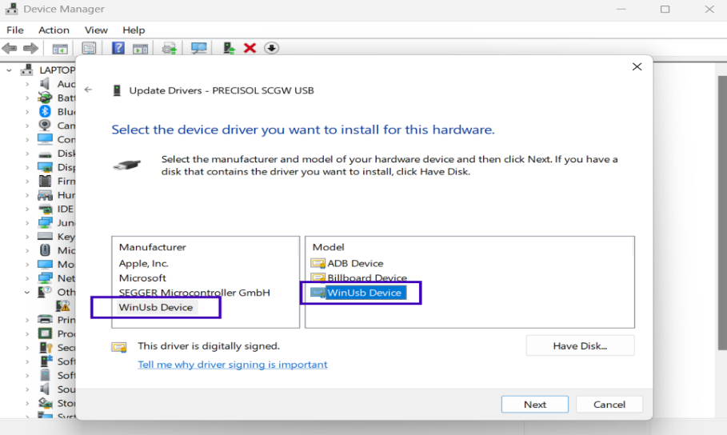

Figure 7: USB driver update – Select WinUsb Device driver

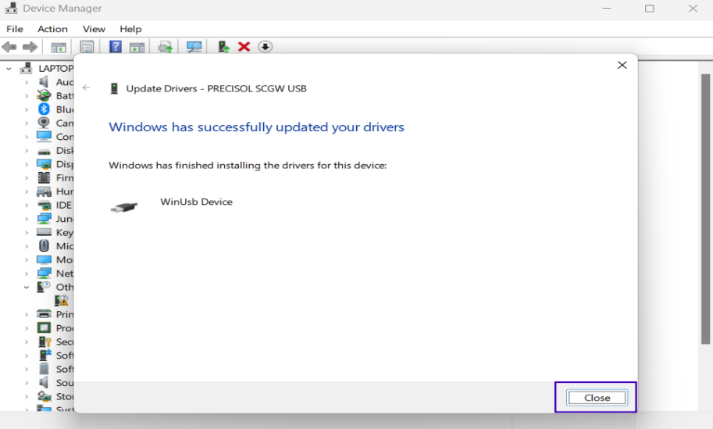

Figure 8: USB driver update – Successful Update

* After a successful device update, "PRESICOL SEGW USB" will be listed under Universal Serial Bus devices.

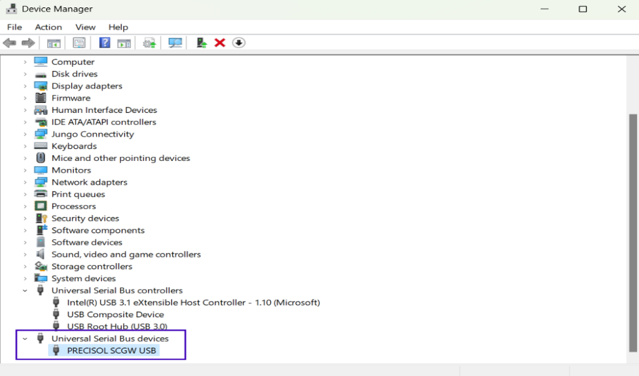

Figure 9: USB driver update – Updated USB device

# PreciCon – Custom Configurator Tool

PreciCon is a custom configuration tool from Precisol Automation for configuring the device settings. Following are the system requirements to setup the PreciCon tool,

* 64-bit PC with at least 4GB RAM and 1 GB free hard disk space.
* 64-bit Java 11 is required. Long-Term Support (LTS) releases are preferred. Currently, Java versions up to 17.0 are compatible with PreciCon.
* For Linux, users can install the jdk11 version using the command “sudo apt install openjdk-11-jre-headless”.
* PreciCon executable file available in the download package.
* USB driver available in the download package.
* For more details, please refer to the document “PreciCon User manual”.

# PreciCloud – Custom Cloud Dashboard

PreciCloud is a readily available cloud dashboard from Precisol Automation for viewing the acquired data graphically using multiple widgets from anywhere at any time. Following are the requirements to setup the PreciCloud dashboard,

* A PC with network connectivity
* Dashboard URL “https://cloud.precisol-automation.com/” is required to view the cloud data.
* Credential provided during purchase of the cloud gateway
* For more details, please refer the document “PreciCloud User manual”

# Device Connection

Gateway requires few connections to be done before power ON as shown in the below image,

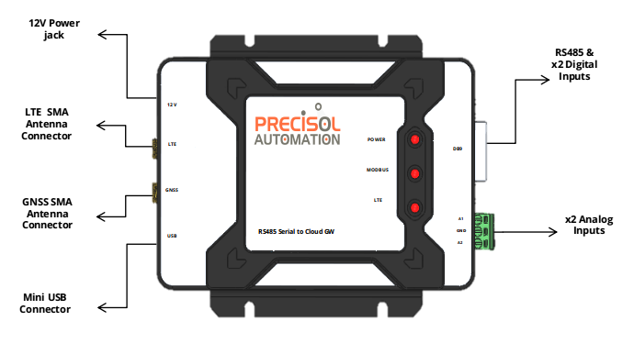

Figure 10: Serial to cloud Gateway – Hardware connections

# Power Supply

Connect 12V DC power supply with 2A current rating provided with the package. If not opted, kindly use the available 12V DC power adapter with at least 1.5A current rating. Barrel connector jack (5.50mm OD) is provided on board for the power input.

# Antenna

Connect the provided LTE & GNSS (if opted) antenna to the gateway’s SMA connector. Make sure the antenna is tightened and flip the antenna right angle to gateway.

# RS485 Serial connection

Connect RS485 A and B signals to your slave device and external digtal input connection by plug in a DB-9 connector. By the following pin details table.

|  |  |  |
| --- | --- | --- |
| PIN NO | DB9 | DESCRIPTION |
| 1 | GND | Ground |
| 2 | DIN2 | Digital Input 2 |
| 3 | B | Bus Output, B |
| 4 | NC | No Connect |
| 5 | GND | Ground |
| 6 | DIN1 | Digital Input 1 |
| 7 | A | Bus Output, A |
| 8 | NC | No Connect |
| 9 | GND | Ground |

# Analog Inputs

For external analog input connection, plug in a 4-pin terminal connector. By using the following pin details table, tightly screw the cables to the terminal block.

|  |  |  |
| --- | --- | --- |
| PIN NO | SIGNAL | DESCRIPTION |
| 1 | A1 | Analog Input 1 |
| 2 | GND | Ground |
| 3 | A2 | Analog Input 2 |

# Digital Inputs

For external device digital inputs connection, plug in a 3-pin terminal connector. By using the following pin details table, tightly screw the cables to the terminal block

|  |  |  |
| --- | --- | --- |
| PIN NO | SIGNAL | DESCRIPTION |
| 1 | GND | Ground |
| 2 | DIN1 | Digital Input 1 |
| 3 | DIN2 | Digital Input 2 |

# Device Configuration

PreciCon tool can be used for configuring the serial settings, Modbus slave register configurations / Produce & Consume configurations, cloud and data upload settings. Connect the Mini USB cable between Gateway and PC before performing device configuration.

# PreciCon

The following screens describes how to configure the device's parameters;

* To begin with, extract the compressed archive - Precicon.zip. folder
* Launch the PreciCon tool by clicking PreciCon > Eclipse> Precicon.exe

# Project Creation

* To create a new project, Right click on the Project Explorer and Click New > Project. In the new project wizard, select a “PreciCon Project” wizard and click the next button to create a new project.
* Enter the project name and project description in this wizard and click the “Finish” button. The new project has been created.

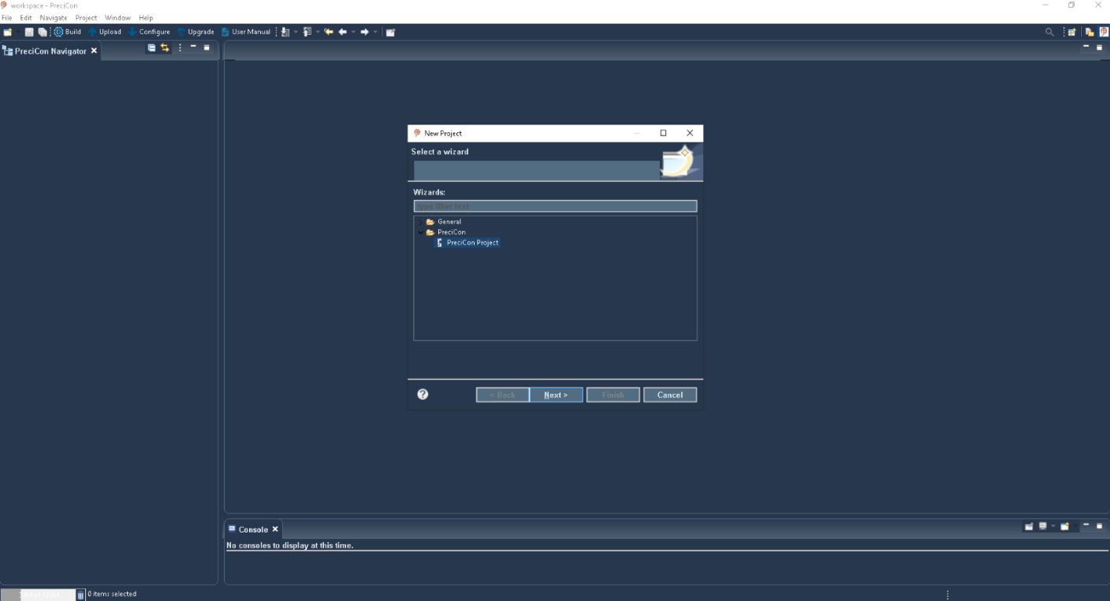

Figure 11: New Project Creation Window

# Device Creation

* To create a new Modbus/Produce &Consume device, right-click the "devices" folder and select new->other. New device creation wizard will be opened. In this wizard, select "PreciCon Device" and click the next button.
* Give this device file a name and click the next button,
* Give the device a label
* Gateway vendor as “Precisol Automation” if you are adding a gateway (Note: Gateway device also need to be added as a device under the project) or
* Select devices vendor as "Rockwell Automation" if you are adding a device under a gateway
* Select type as “Gateway” for gateway or “Sensor” for flowmeter, energy meter, etc
* Select device variant as PA SG-RS485MC if you are adding a gateway or
* Device variant as Flowmeter, Energy meter or any preferred device variant
* Click the “finish” button
* Now new Modbus/ Produce &Consume device (.pcd) file will be created under devices.

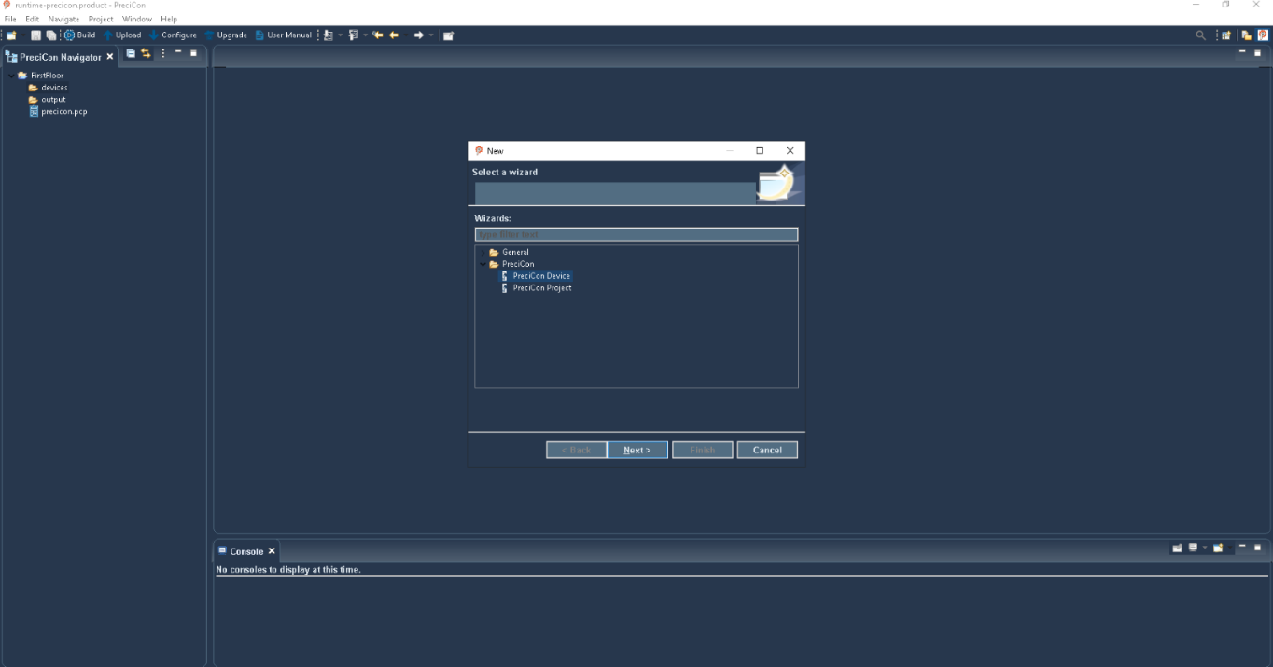

Figure 12: Device Creation Window

# Serial Configuration

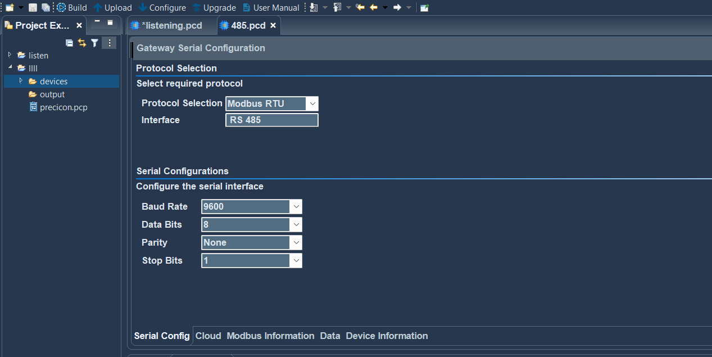Serial protocol, serial settings such as baud rate, data bits, parity, flow control etc. can be configured in the serial tab.

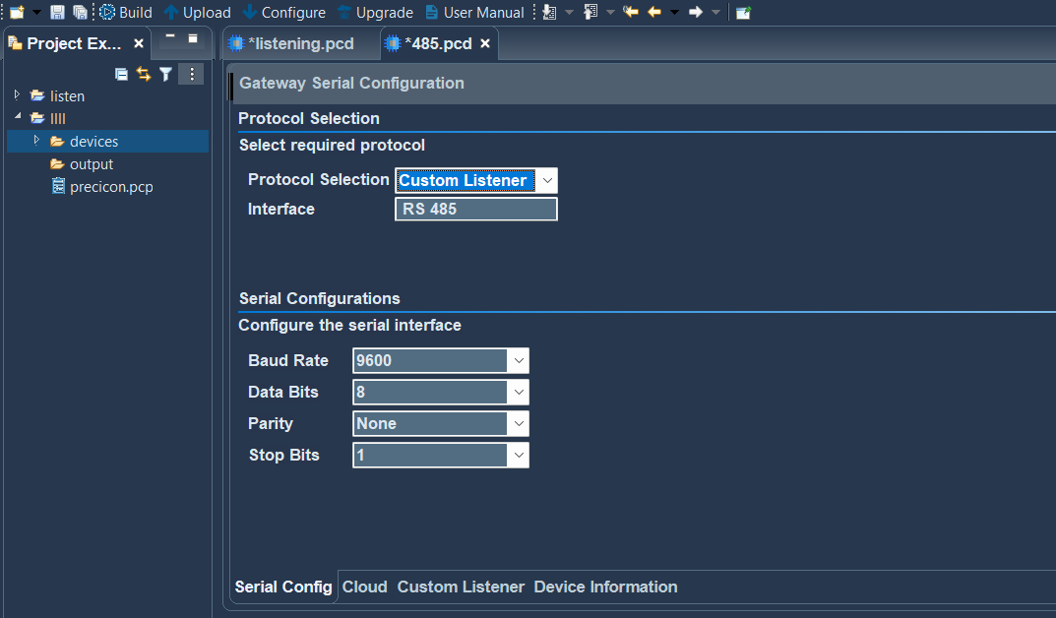Figure 13: Modbus - Serial Configuration Window

Figure 14: Produce & Consume - Serial Configuration Window

# Modbus Configuration

Serial Modbus is supported for up to 16 register addresses. Modbus configurations can be constructed for 4 devices, each of which can carry up to four register addresses, totaling 16 addresses.

Device 1

Register 1

Register 2

Register 3

Register 4

Device 2

Register 1

Register 2

Register 3

Register 4

Device 3

Register 1

Register 2

Register 3

Register 4

Device 4

Register 1

Register 2

Register 3

Register 4

Figure 15: Modbus device structure Details

Following Modbus function register types are supported,

* + - Read Coils
    - Read Discrete Inputs
    - Read Holding Registers
    - Read Input Registers

Following Modbus Storage data types are supported

* + - Unsigned 8-bit integer
    - Signed 8-bit integer
    - Unsigned 16-bit integer
    - Signed 16-bit integer
    - Unsigned 32-bit big-endian integer
    - Unsigned 32-bit little-endian integer
    - Unsigned 32-bit, big-endian byte swap integer
    - Unsigned 32-bit, little-endian byte swap integer
    - signed 32-bit big-endian integer
    - signed 32-bit little-endian integer
    - signed 32-bit big-endian byte swap integer
    - Signed 32-bit, little-endian byte swap integer
    - Single precision big-endian integer
    - single precision little-endian integer
    - Single precision big-endian byte swap integer
    - Single precision little-endian byte swap integer
    - Double precision big-endian integer
    - Double precision little-endian integer
    - Double precision big-endian byte swap integer
    - Double precision little-endian byte swap integer

In the data information table of the Modbus device, there are default data values that are non-editable. Additionally, new data settings can be configured, which include the data name, type, and unit.

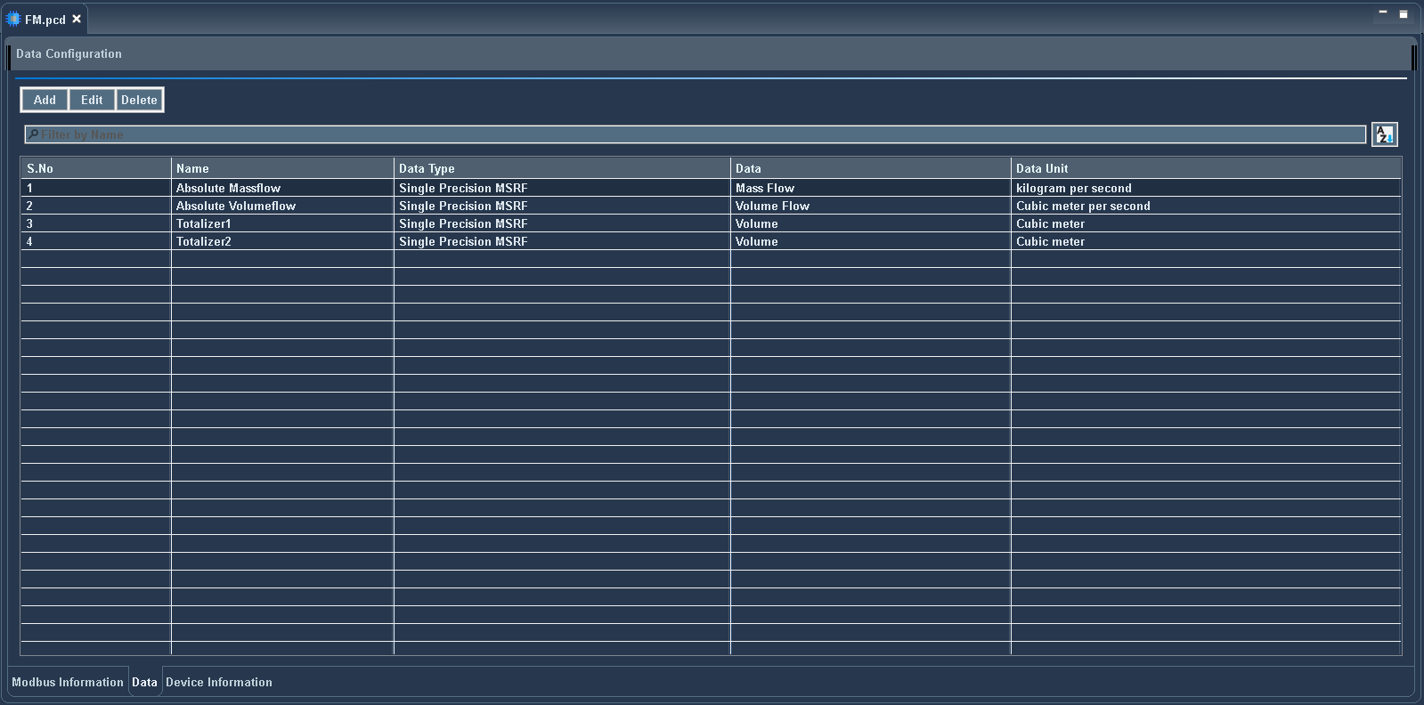

Figure 16: Data Information Table

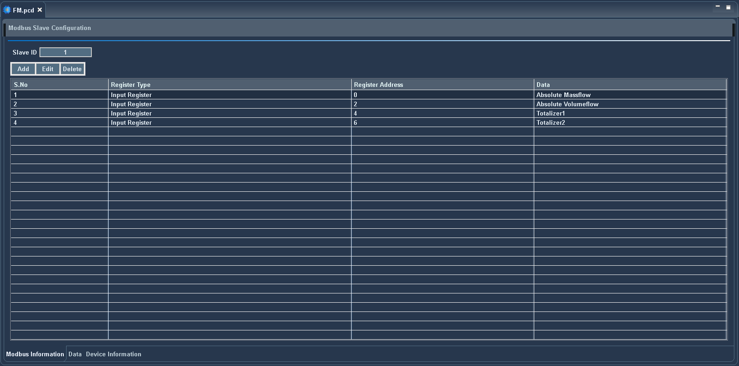In the Modbus information table, there are default Modbus values that are non-editable. Also, new Modbus settings can be configured, which include register type, Modbus register address, and data. 

Figure 17: Modbus Information Table

# Produce & Consume Configuration

The Produce & Consume provides continuous data listening over the serial interface as well as data processing depending on the start and end characters.

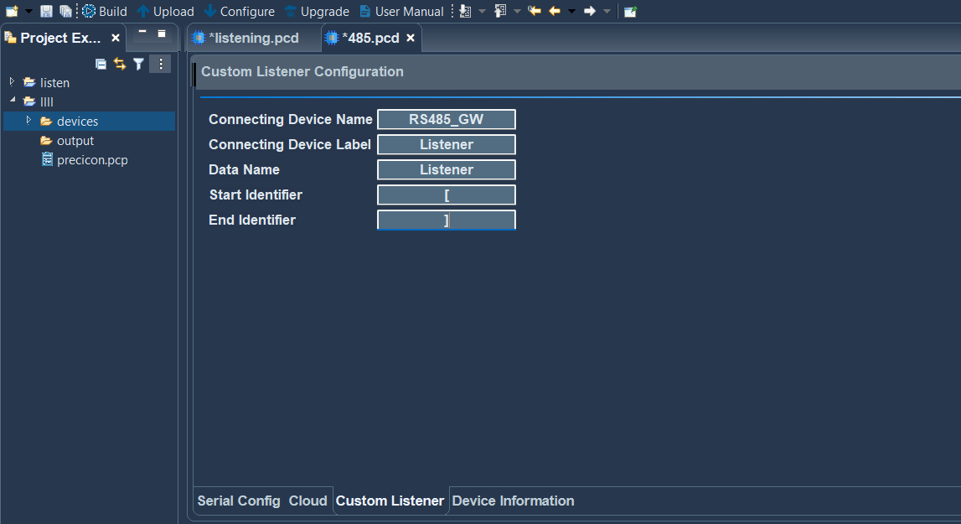

Figure 18: Produce & Consume Configuration

**Note**: Start Identifier and End Identifier must not contain a same value.

Identifier value can be anything expect for the below two characters

1. “

2. \

# Cloud Upload Configuration

To send data to the cloud, protocol, QOS, user name, password, ssl, URL, access token, start time, time interval, and selection of the data that are to be sent to the cloud must be configured. In the cloud tab, all the devices with their configured data for that project are listed in a table. Select the data to which you want to send a cloud.

Modbus / Produce & Consume configuration can be processed only through MQTT.

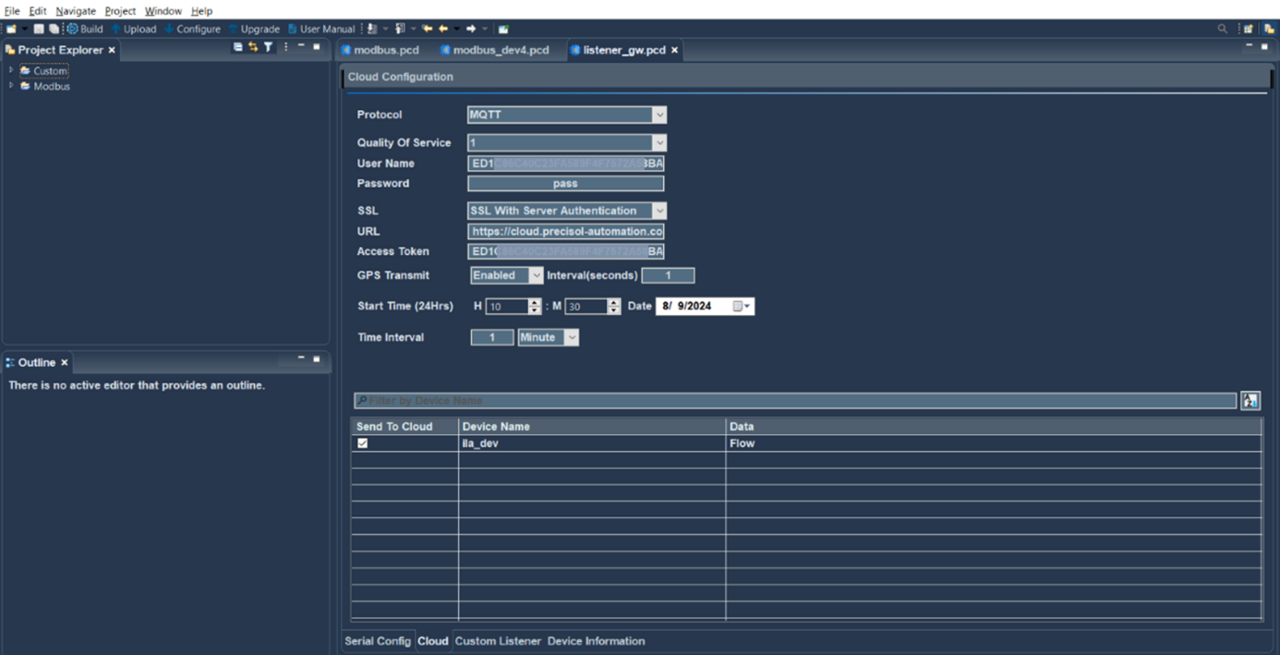

Figure 19: Cloud Upload Configuration Window

# USB Device Configuration

To initiate data configuration on the device, it's important to have both USB cable connectivity and power supply. Select the project to which you want to configure and simply click the "Configure" button, then designated settings will be transmitted to the device.

# Remote Device Configuration

Cellular network connectivity in the device is essential for remote configuration. To configure the settings to the device from remote location, select the project and click the "Upload" button. The configuration will be uploaded to the device.

# Configuration Status

The PreciCloud allows users to view the status of device configuration details from a device perspective.

Configuration status is classified into the following error codes.

|  |  |
| --- | --- |
| Status | Description |
| PENDING | Configuration queued and waiting for the gateway response |
| PROCESSING | Gateway received the serial configuration |
| SUCCESS | Successful configuration update |
| FAILED [E201] | Configuration Update Timeout occurred / Gateway name change failure |
| FAILED [E202] | Device Configuration request to PreciCloud failed |
| FAILED [E203] | Received Configuration JSON validation Error |

# Modbus Write Configuration

The serial Modbus write feature is supported for up to four register addresses at once.

Serial Modbus write settings such as slave ID, register address, storage type, function code, etc. can be configured in the PreciCloud dashboard.

Modbus write configuration can also be processed either through MQTT or HTTP.

Following Modbus write function register types are supported,

* Write Single Coil
* Write Single Register
* Write Multiple Coils
* Write Multiple Registers

# PreciCloud

Below is the PreciCloud dashboard with details of gateways and device.

All the gateways will be listed in the dashboard with primary information such as type, signal strength, etc. Also, the gateway online/offline status will be available in this view.

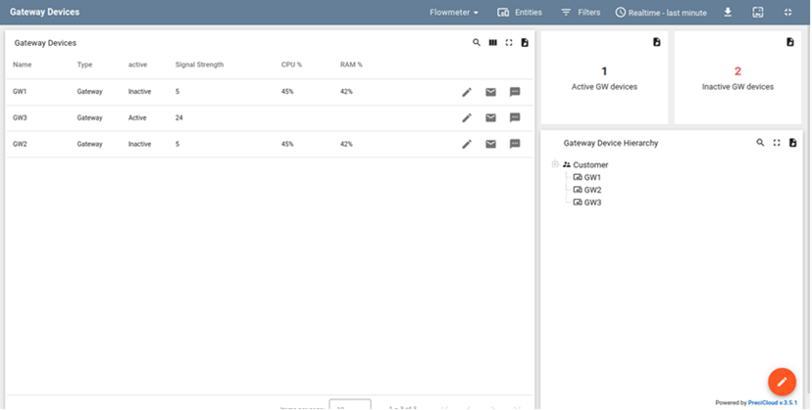

Figure 20: Dashboard with Gateway Details

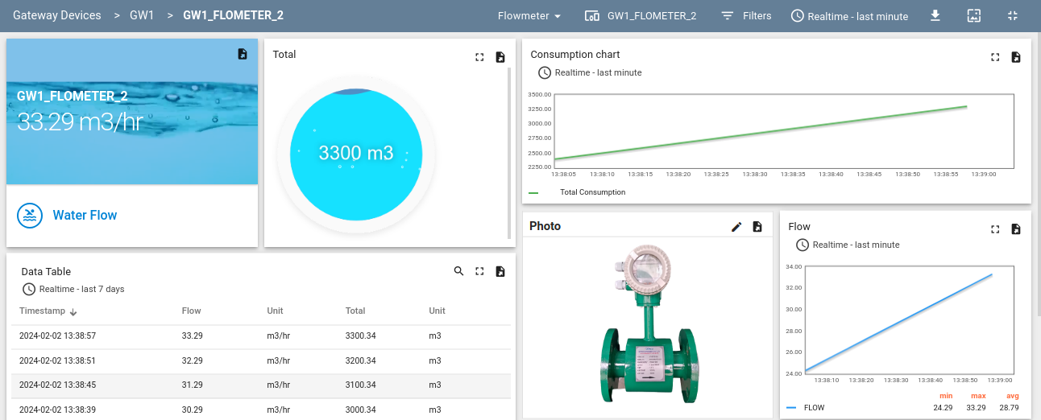Acquired data from a device under the gateway will be listed in the devices view. This view can be edited by the customer were widgets, tables, charts can be added.

Figure 21: Dashboard with Modbus Device Details

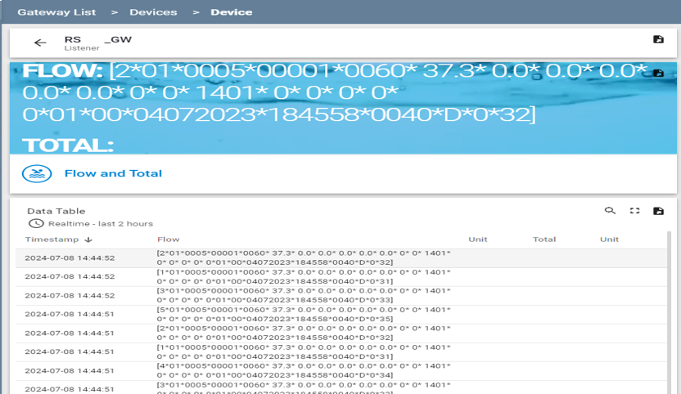

Figure 22: Dashboard with Produce & Consume Device Details

# Firmware Upgrade Process

Firmware updates allow devices to continue to run efficiently and securely. These updates often entail some type of software modification that improves a known flaw or provides protection against certain vulnerabilities.

Firmware file versions are in the form of X.YY.ZZ,

* + X - indicates Major Version
  + Y - indicates Minor Version
  + Z- indicates Patch Version

Firmware upgrades can be initiated using either PreciCloud or the PreciCon utility.

# FOTA via PreciCloud

Firmware can be updated Over-The-Air via PreciCloud. Users need to follow the below procedure to upgrade the firmware,

* FOTA can be initiated from the PreciCloud (server end) by uploading the firmware file.
* The firmware file must be in binary format that is being shared by Precisol Automation.
* The gateway acknowledges the cloud-based firmware upgrade request.
* Gateway downloads and validates the firmware file to prevent tampering.
* Firmware upgrade takes 5 to 10 minutes to complete successfully.
* The device executes existing firmware applications, if the firmware upgrade fails due to a validation issue.
* If there is no network connection throughout the FOTA process, the device will continue to try to download the firmware file until the upgrade process is complete.
* Firmware upgrade through USB can also be used instead of cloud If the device tries continuing to download the firmware file

# Upgrade through USB

Firmware can be also updated via PreciCon configurator tool using USB interface. Users need to follow the below procedure to upgrade the firmware,

* Firmware upgrade can be initiated from the PreciCon tool by uploading the firmware file.
* The firmware file must be in binary format.
* The gateway acknowledges the USB-based firmware upgrade request.
* Gateway downloads and validates the firmware file to prevent tampering.
* Firmware upgrade takes 10 seconds to a minute to complete successfully.
* The device executes existing firmware applications, if the firmware upgrade fails due to a validation issue.

# Firmware Upgrade & Connection Status

Firmware Upgrade status is classified into the following which can be viewed in PreciCloud.

|  |  |
| --- | --- |
| Status | Description |
| Queued | Firmware file currently queued for the upgrade in the PreciCloud |
| Initiated | Gateway received the firmware upgrade info and initiated the process |
| Downloading | Gateway started downloading the firmware file |
| Downloaded | Gateway successfully downloaded the firmware file |
| Verified | Gateway validated the firmware file |
| Failed | Firmware upgrade failed |
| Connected | Current firmware version is sent when Gateway is powered ON |
| Re-connected | Current firmware version is sent when PreciCloud is reconnected |

Firmware upgrade **Failure** reasons can be due to invalid firmware file (corrupted file or wrong format file).

# LED Indication

There are three LED’s available in the device for various indications. Details of indications as follows,

|  |  |  |
| --- | --- | --- |
| LED | Condition | Status |
| Power LED (Red) | On | Device Power on |
| Serial Communication LED (Green) | Fast blink | Modbus communication failure. (500ms - toggling)  Produce & Consume serial Data processing. (500ms - toggling) |
| Slow blink | When Modbus client / Produce & Consume is activated and running. (1000ms - toggling) |
| Solid state | Firmware upgrade process |
| Off | Modbus client is stopped or deactivated |
| Cloud Communication LED (Green) | Fast blink | Registered to the network and IP address is attained  (500ms - toggling) |
| Slow blink | Registered to the PreciCloud and internet is available |
| Solid state | Firmware upgrade process |
| Off | Not registered to the network |

# FAQ

* Why power LED is off?

Please check the device power supply have 12 V.

* Why Cloud communication LED is off?

When network is not registered, or internet is not available.

* Why USB not detected?

Verify the USB connection and ensure device driver is installed in the PC

* Why signal strength is low?

Ensure the LTE antenna is connected to the board and ensure the local area LTE/2G network availability