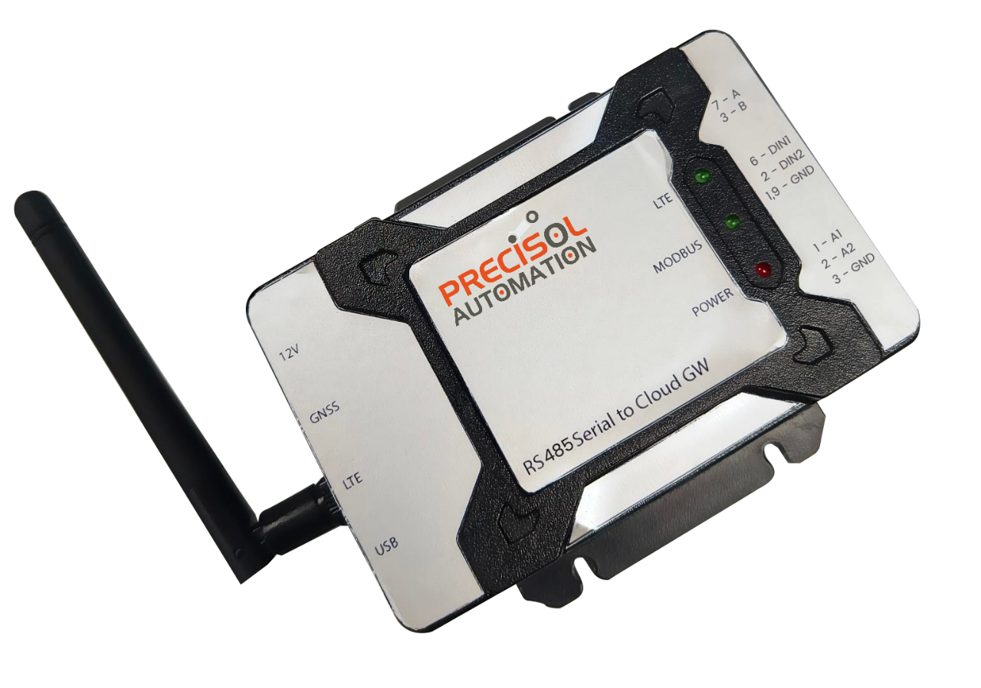

Sense for Machines

RS485 Serial to Cloud Gateway

*Product Specification Document*

*Version 1.0*

PreciCloud – Cloud Dashboard

A customized cloud dashboard for viewing the acquired data from anywhere at any time. Following options are provided by PreciCloud,

* + Secure Login with different user modes
  + Multiple widgets for general data sets such as temperature, pressure, flow, level, etc
  + Detailed info about GW/slave device setup
  + Remote device configuration
  + OTA device upgrade
  + Periodic email notifications
  + SMS alerts

RS485 Serial to Cloud Gateway

A compact and robust industrial grade cloud gateway, ideally suitable for acquiring data from RS485 enabled devices at required periodicity and upload the same to cloud for remote monitoring.

The key advantage of this device is its capability to support multiple serial protocols like Modbus RTU, Modbus ASCII, Produce & Consume and Custom Request Response. The gateway device is specially designed to withstand the harsh industrial environment with the robust IP40 enclosure and it is more user friendly with minimal efforts required for commissioning.

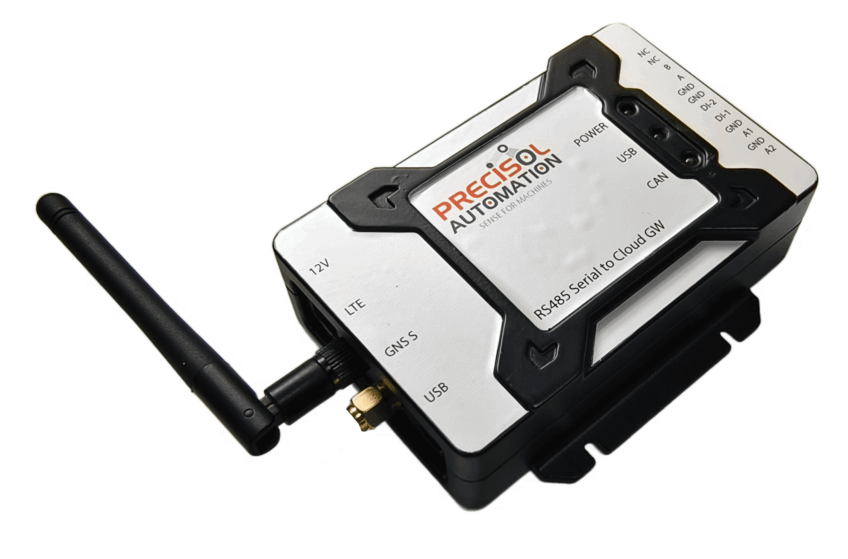

Zero Data Loss

IP40 Rating Enclosure

Periodic Upload

OTA - Firmware and configuration

Modbus RTU/ASCII protocol

PreciCon configurator tool

PreciCloud Cloud platform

Highlights

Key Features

* Reliable acquisition of data from any serial RS485 enabled industrial devices
* Support various serial protocols,
  + - Modbus RTU
    - Modbus ASCII
    - Produce & Consume
    - Custom Request Response
* LTE cellular connectivity with 2G network fallback capability
* Real Time Clock with network time synchronization
* Loss-less data acquisition using internal memory for storing data during network disconnection.
  + Optional and should be specified during ordering
* Three LEDs for power, Modbus and network communication indications
  + Multiple patterns for different statuses
* Two channel digital inputs for capturing external events from sensors, PLCs, etc
* Two channel analog inputs for measuring analog current output from sensors
* Optional GNSS support
* Provided together with M2M Simcard

PreciCon – Configurator Tool

* Support for configuring,
  + Serial settings
  + Modbus slave register configurations
  + Cloud settings
  + Data upload interval, etc
* USB based PC interface for device communication
* Support for both Linux and Windows PC operation
* Supports export/import of device configurations
* Support for uploading configurations to cloud

|  |  |
| --- | --- |
| Function | RS485 Serial to Cloud Gateway |
| Power Supply | 12V DC |
| Power consumption | 1.5A Max @12V |
| PC interface | USB Mini B connector  USB device communication for configuration using PreciCon tool |
| RS485 Serial Interface | External interface via DB-9 connector  Data bits: 7 and 8 bits  Baud Rate: 300, 600, 1200, 2400, 4800, 9600, 14400, 19200, 38400, 57600, 115200, 128000 and 256000 bps  Stop bits: 1, 2 bits  Parity: None, Odd and Even |
| Environmental | Dimension: 105mm X 68mm X 31.5mm (W/O flanges)  Weight: 138 gm  ABS plastic (IP40)  Operating Temperature: -40 to +85 Degree Celsius |
| Data storage Capability | Non-Removable microSD card  8 to 32GByte |
| Status Indication | LED 1 for Power status  LED 2 for Serial communication status  LED 3 for Cloud network communication status |
| Analog input | |
| Number of channels | 2 |
| Range | Current Input – 4mA to 20mA |
| Resolution | 16-bit |
| Input impedance | 120 ohms |

Technical Specifications

|  |  |
| --- | --- |
| Function | RS485 Serial to Cloud Gateway |
| Digital Input | |
| Number of channels | 2 |
| Input Switching Threshold | High = Greater than 3V or 1.5V (optional, to be mentioned during ordering)  Low = Less than 3V or 1.5V (optional, to be mentioned during ordering) |
| Voltage input limit | 30V Max |
| Cellular Connectivity | |
| LTE Category | LTE CAT 1  Support for global coverage including Europe, US, Asia-Pacific, etc (optional, to be mentioned during ordering) |
| Bands | LTE-FDD: B1/3/5/8  LTE-TDD: B34/38/39/40/41  GSM: B3/8 |
| Antenna | SMA connector for external finger type or expandable antenna |
| SIM interface | Inbuilt non-removable Micro SIM card |
| Cloud Data Transfer | |
| Data format | * Log data in industry standard format. * Cyclic Logging support – Oldest file will be deleted when storage is full. * 100% power safe data logging - no file corruption when disconnected. |

|  |  |
| --- | --- |
| Function | RS485 Serial to Cloud Gateway |
| Cloud Data Transfer | |
| Time Stamp | * Inbuilt RTC with year, month, date, weekday, hours, minutes, seconds, and milliseconds data * RTC can be configured to match local time zone. * RTC can be auto-synced via LTE network. |
| UID | * Each device has a globally unique ID ensuring unique log file naming. |
| Diagnostics | * Periodic heartbeat to cloud for connection supervision |
| Product Deliverables | |
| * One Unit with IP40 rated ABS plastic enclosure * PreciCon - Windows / Linux OS based application for configuration * PreciCloud – Cloud application with individual login per user * One LTE Antenna * One pluggable terminal connector for RS485 interface * User Manual * Quick Start Guide | |