

Sense for Machines

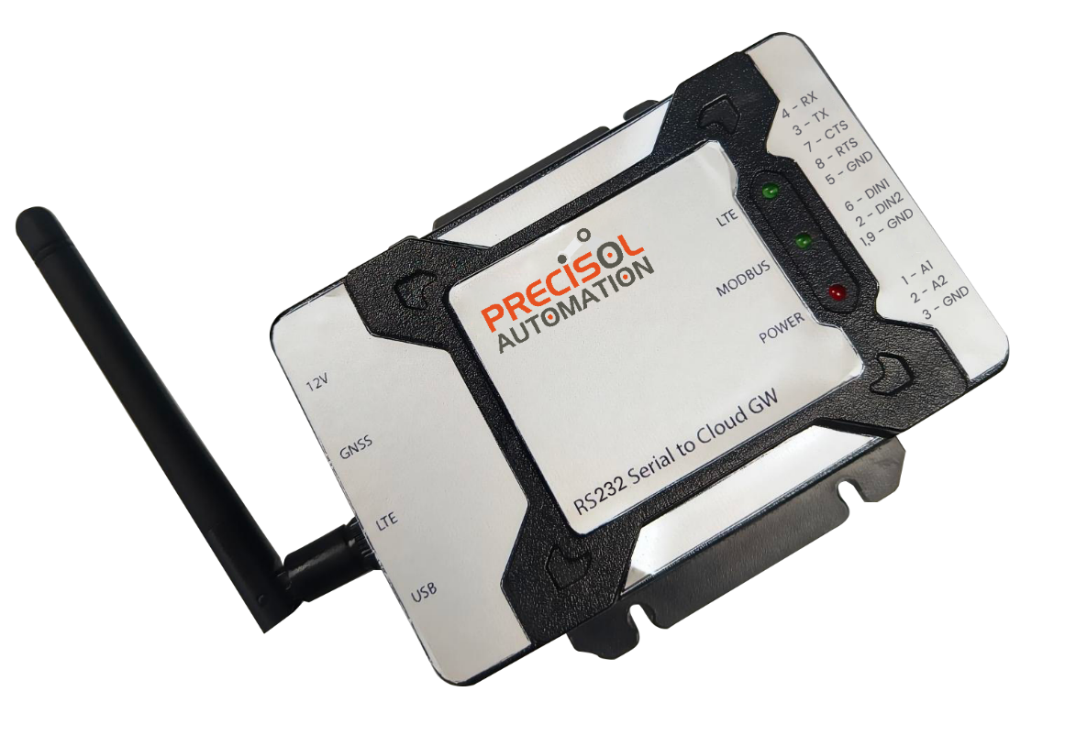

RS232 Serial to Cloud Gateway

*Quick Start Guide*

*Version 1.0*

Contents

1. About 3

2. Kit Contents 3

3. RS232 Serial to Cloud Gateway Device Specification 4

4. Setting up the system 5

# About

This quick start guide will provide the details about the kit contents, device hardware terminal details, power on and device setting information.

# Kit Contents

The standard package includes below listed items,

* RS232 Serial to Cloud Gateway
* 12V DC power adapter (Optional)
* 1x LTE antenna (Rubber Duck Antenna)
* 1x GPS extendable wire antenna (Optional)
* Mini USB B to USB type A converter cable (Optional)
* 3-Pin mating connector for Digital input (Optional)

|  |  |  |
| --- | --- | --- |
|  | 3dbi-rubber-duck-antenna-with-sma-male-movable-connector | miniusb |
| RS232 SERIAL TO CLOUD GATEWAY | 4G 3DBI RUBBER DUCK LTE ANTENNA | EBKA-03-BMini USB B to USB type A converter CABLE |
| 12v-2amp-adaptor-550x550w |  |  |
| 12V DC POWER ADAPTER | GPS ANTENNA | 3-PIN MATING CONNECTOR |

Figure 1 Kit Contents

# RS232 Serial to Cloud Gateway Device Specification

The following section will describe the hardware terminal details of the device.

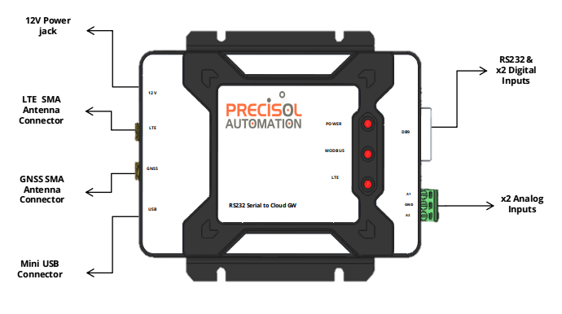 Figure 2 Pictorial representation of Serial to Cloud Gateway

|  |  |
| --- | --- |
| Function | RS232 Serial to Cloud Gateway |
| Power Supply | 12V DC |
| Power consumption | 1.5A Max @12V |
| PC interface | USB Mini B connector  USB device communication for configuration using PreciCon tool  External interface via DB-9 connector |
| RS232 Serial Interface | External interface via pluggable terminal connector  Data bits: 7,8 bits  Baud Rate: 300, 600, 1200, 2400, 4800, 9600, 14400, 19200, 38400, 57600, 115200, 128000, 256000, bps  Stop bits: 1, 2 bits  Parity: None, Odd and Even  Flow Control: OFF, RTS/CTS |
| Status Indication | LED 1 for Cloud network communication status  LED 2 for Serial communication status  LED 3 for Power status |

|  |  |
| --- | --- |
| Analog input | |
| Number of channels | 2 |
| Range | Current Input – 4mA to 20mA |
| Resolution | 16-bit |
| Input impedance | 120 ohms |
| 4G LTE | |
| LTE Category | LTE CAT 1  Support for global coverage including Europe, US, Asia-Pacific, etc (optional, to be mentioned during ordering) |
| Bands | LTE-FDD: B1/3/5/8  LTE-TDD: B34/38/39/40/41  GSM: B3/8 |
| Antenna | SMA connector for external finger type or expandable antenna |
| SIM interface | Inbuilt non-removable Micro SIM card |

# Setting up the system

The following section will describe how to setup and run the Gateway with your slave Modbus

device.

Note: PreciCon and PreciCloud tools should be downloaded and installed in the PC before starting the gateway setup.

* PreciCon tool download link: <https://precisol-automation.com/rs232-serial-to-cloud-gateway/>
* PreciCloud dashboard link: <http://cloud.precisol-automation.com>

|  |  |
| --- | --- |
| 1Connect your Modbus Device  Connect RS232 A and B signals to your slave device. Check whether the wires are rigidly connected and if there is no loose connection in between the device & gateway.  Also check the DB-9 connector is properly plugged to the gateway. | 2 Connect the Antennas  Connect the provided LTE & GNSS (if opted) antenna to the gateway’s SMA connector. Make sure the antenna is tightened to the correct SMA connector properly.  Flip the antenna so that it will be right angled to the gateway. |
| 3 Connect the Inputs  Connect your device's analog and digital output from the sensor or slave device to the gateway input terminal via 3-pin terminal connector and DB-9 connector respectively.  Screw the analog input wire to the mating connector and plug the mating connector to the gateway. Make sure the wires are screwed tightly and there are no loose connections. | 4 Connect the Power Supply  Power the gateway with the 12V DC power supply provided with the package. If not opted, kindly use the standard 12V/1.5A DC power adapter.  Make sure the adapter connector will mate with the gateway’s 5.50mm OD barrel connector.  The power LED will turn on once the device is powered up. |
| 5 Configure your Gateway  Connect the Gateway via USB cable to the PC installed with PreciCon (Custom configurator) tool.  Enter the gateway’s serial settings, Modbus parameters, cloud settings, etc.  Download the configurations to the gateway. Cloud LED will be turned OFF and ON during USB communication. Once complete, the cloud connection status will be notified. | 6 View the live data  Users can view the live acquired data in PreciCloud, a custom cloud dashboard. Login to the PreciCloud using the provided credentials.  The gateway will communicate with the cloud continuously after successful configuration and the Cloud LED will notify the communication status.  All the configured Modbus device data will be available in the cloud dashboard. |

|  |  |
| --- | --- |
| SUPPORT  For any support, Connect the Gateway via USB cable to the PC installed with PreciCon (Custom configurator) tool. | WARRANTY  To Claim warranty for the device, Connect to the Gateway via USB cable to the PC installed with PreciCon (Custom configurator) tool. |

*For further information, refer to the user manual of the gateway, PreciCon and PreciCloud.*