

**.**

Sense for Machines

PreciCloud

*User Manual*

*Version 1.0*

*Table of Content*

1. INTRODUCTION 5

2. SYSTEM HIERARCHY CHART 5

3. USER ROLES 6

3.1 System Admin 6

3.2 Tenants 6

3.3 Tenant Admin 7

3.4 Customer 7

4. GETTING STARTED 8

4.1 Login Screen 8

4.2 Customer Creation 10

4.2.1 Customer User Creation 11

4.2.2 Dashboard 12

4.2.3 Admin - Flowmeter Dashboard 13

4.2.3.1 Scheduler 18

4.2.3.2 Gateway Info 21

5. OTA UPDATES 25

5.1 Assign OTA Package to Device 27

5.2 Assign OTA Package to Device Profile 28

6. CUSTOMER 29

6.1 Login Screen 29

6.2 Home 29

6.3 Dashboards 31

6.4 Notification Center 33

7. USERS PROFILE 34

7.1 Profile Screen 34

7.2 Security Screen 35

7.3 Logout 36

8. LIMITATIONS 37

*Table of Figures*

Figure 1 System Hierarchy 5

Figure 2 User Roles and Permission flow 6

Figure 3 Password creation page 8

Figure 4 Tenant Admin Login Screen 9

Figure 5 Tenant Home Screen 9

Figure 6 Customer Page 10

Figure 7 Customer Creation Screen 10

Figure 8 Customer List 11

Figure 9 Customer User Page 11

Figure 10 Add User Screen 11

Figure 11 User List 12

Figure 12 Dashboard List 12

Figure 13 Flowmeter Dashboard 13

Figure 14 Flowmeter Dashboard 13

Figure 15 Active Gateway List 14

Figure 16 Inactive Gateway List 14

Figure 17 Edit Gateway Info 14

Figure 18 Gateway Device List 15

Figure 19 Active Devices 15

Figure 20 Inactive Devices 15

Figure 21 Consumption Details 16

Figure 22 Edit Device Label 16

Figure 23 Edit Device Location 17

Figure 24 Flowmeter Info (i) 17

Figure 25 Flowmeter Info (ii) 17

Figure 26 Edit Additional Info 18

Figure 27 Mail Config 18

Figure 28 Mail Configuration Screen 19

Figure 29 Mail Configuration 19

Figure 30 Mail Configuration Schedule tab 20

Figure 31 Sample Email Data 21

Figure 32 Gateway Info State 21

Figure 33 Gateway Info widget 22

Figure 34 Firmware Info widget 22

Figure 35 Edir Firmware Version 23

Figure 36 Device Profile with Assigned Firmware 23

Figure 37 Update Firmware for Device Profile 24

Figure 38 Gateway Configuration Details Widget 24

Figure 39 View Gateway Configuration 25

Figure 40 Add OTA Package 26

Figure 41 Firmware Dashboard 27

Figure 42 Edit Gateway Firmware 27

Figure 43 Edit Device Profile Firmware 28

Figure 44 Customer Login Screen 29

Figure 45 Customer Home Page 30

Figure 46 Gateway Device List 30

Figure 47 Flowmeter Info 31

Figure 48 Consumption Details 31

Figure 49 Customer Dashboards 32

Figure 50 Notification Screen 32

Figure 51 User Account 33

Figure 52 User Profile Screen 34

Figure 53 User Security Screen 34

Figure 54 Welcome Screen after Logout 35

1. INTRODUCTION

PreciCloud is an IoT platform that enables rapid development, management, and scaling of IoT applications. Our goal is to provide the out-of-the-box IoT cloud or on-premises solution that will enable server-side infrastructure for the IoT applications.

1. SYSTEM HIERARCHY CHART

Below section will shows the hierarchy of the system,

System Admin

Tenant-3

Tenant-2

Tenant-1

Tenant User-1

Tenant User-2

Tenant User-3

Devices

Customer

Assets*

Dashboard

Dashboard

Devices

Customer User-1

Customer User-2

Customer User-3

Figure 1 System Hierarchy

1. USER ROLES

The different user roles and their privileges details is captured in the following section.

Below flow chart will shows the roles and their privileges,

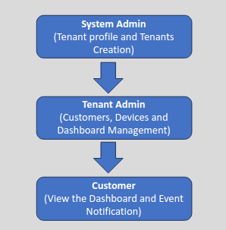

Figure 2 User Roles and Permission flow

* 1. System Admin

System Admin has the privilege to create Tenant Profile, Tenant, Tenant Users and Gateway. Each tenant can have multiple Tenant users.

* **Tenant Profile**

Tenant Profile is a group of Tenants with common configuration. One tenant can be added to only one profile at a single point of time. This configuration includes limitation on number of entities created by a tenant, maximum number of messages, API calls per month, maximum number of requests the platform should process for a specific device (device-level) or for all devices belonging to a single tenant (tenant-level), etc.

* 1. Tenants

Tenant is a separate business-entity: individual or organization who owns or produces devices and assets.

Tenant may have multiple tenant administrator users, users, enormous number of [customers](https://thingsboard.io/docs/user-guide/ui/customers), and an unlimited number of assets, and devices.

* 1. Tenant Admin

Tenant Admin is a user in the Tenants level with following privileges.

* Manage Devices.
* Create and Manage Customers.
* Create and Manage Customer Users.
* Create and Manage Dashboards.

Tenant Admin users can able to create customers and assign them to their devices. Tenant Admins can also have the privileges to upload firmware or software packages to the OTA repository.

* + Once the Firmware file has been uploaded, Tenant admin may assign them to Device Profile or Device. PreciCloud will notify the devices about the available update and provide a protocol-specific API to download the uploaded firmware file.
  + The platform tracks the status of the update and stores the history of the update. As a platform user, Tenant Admin can monitor the update process using the dashboard.

A Tenant can have multiple Tenant Admins which should be created by the System Admin.

* 1. Customer

The customer profile is also a separate business-entity. A customer may be an individual or an organization who purchases or uses tenant devices and/or assets. Customer may have multiple users and millions of devices and/or assets

A customer is the end user created by Tenant Admin, who only has the view permissions to their assigned Dashboards and event Notifications.

1. GETTING STARTED

* To get access to the PreciCloud, the Tenant user should get an invite email from Precisol Automation along with the activation link.
* Click the link to land on the Password creation page.
* Enter the new password, reenter the password and click submit.

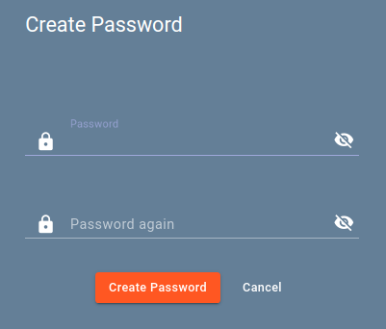

Figure 3 Password creation page

* After successful creation of the password, it will be redirected to the dashboard.
* PreciCloud can also be opened using the link [https://cloud.precisol-automation.com](https://cloud.precisol-automation.com/login)

Once, the user sets the password for the first time.

* 1. Login Screen
* Open the PreciCloud web application ([cloud.precisol-automation.com](https://cloud.precisol-automation.com/login)). Enter the Tenant Admin login credentials and click login button

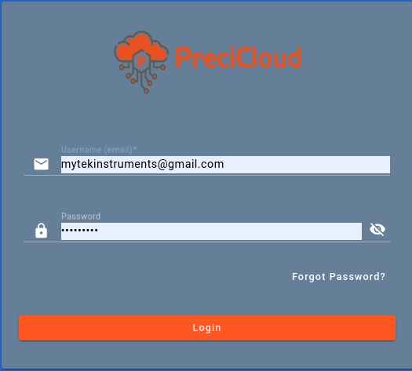

Figure 4 Tenant Admin Login Screen

* Upon successful login, the tenant will be directed to the home screen. On home screen, Tenant users can access the default dashboard assigned by the System Admin. (For instance, the default dashboard is the Flowmeter Dashboard which is shown below)

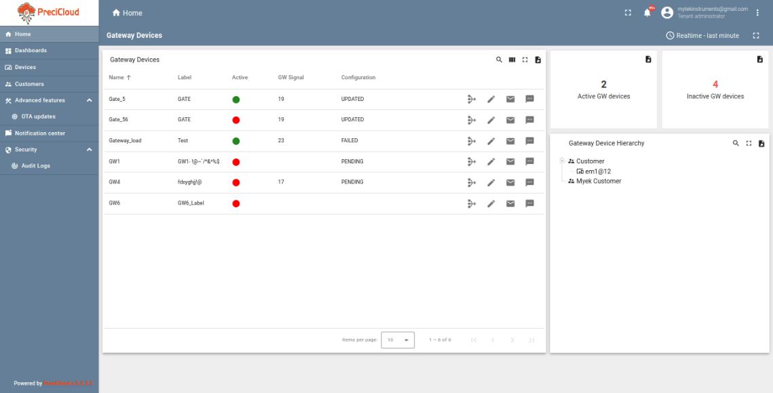

Figure 5 Tenant Home Screen

* 1. Customer Creation
* For Customer creation, Navigate to the "Customers" page.
* Then click the plus sign in the upper right corner of the screen.

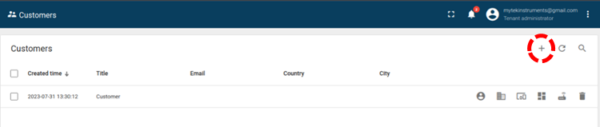

Figure 6 Customer Page

* Add customer dialog will be opened.
* Fill in the customer details (Title is Mandatory and other details are optional.) and click "Add".

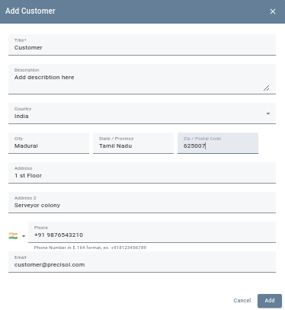

Figure 7 Customer Creation Screen

* New customer has been created successfully after clicking the “Add” button.
  + 1. Customer User Creation
* 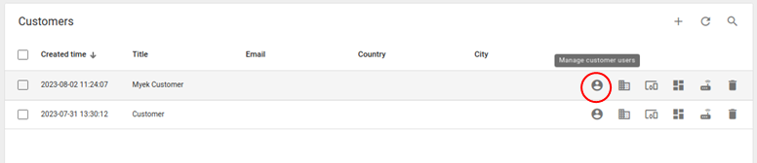Click on the "Manage Customer Users" icon located on the customer`s row to whom you want to add a customer user.

Figure 8 Customer List

* Click the plus sign in the upper right corner of the screen.

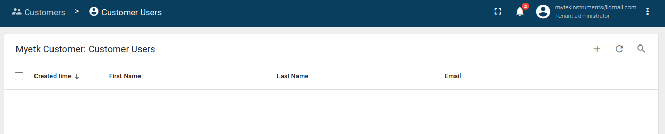

Figure 9 Customer User Page

* In the opened dialog box, enter the email address, first and last name of the user. Choose activation method: display activation link or send activation link via email. Then click "Add"
* Select the option "Display activation link", copy the link address and send it to the user then click "OK"

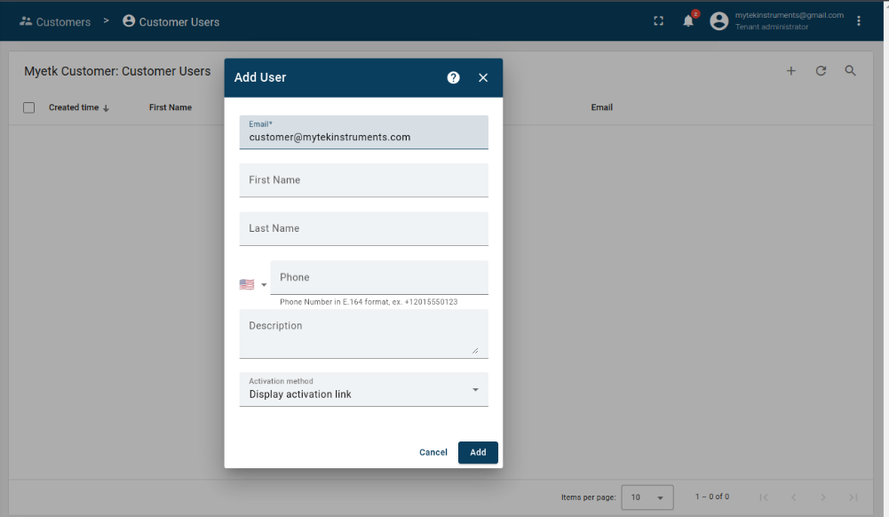

Figure 10 Add User Screen

* New customer user is created successfully.

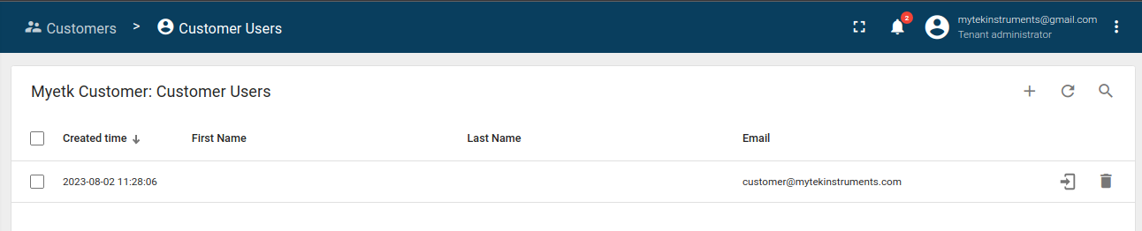

Figure 11 User List

* Tenant Admin can able to create “Multiple Users” for a customer. Tenant Admin can also be able to create multiple customers.
  + 1. Dashboard
* To view the Dashboard, Navigate the current screen to the "Dashboard" page.
* A list of dashboards created by system admin will be displayed.
* Users can use the widget and create dashboard as they want.
* PreciCloud supports widgets like,
* Entities Table
* HTML value card
* Entities hierarchy
* OpenStreetMap
* Timeseries table
* Timeseries Line Chart, etc.
* Click the Flowmeter dashboard under the Dashboard table,

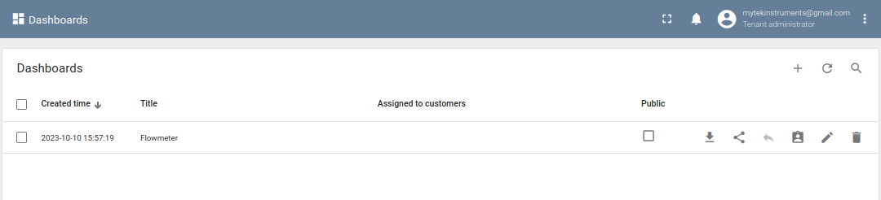

Figure 12 Dashboard List

* The Flowmeter dashboard will show the list of widgets such as Gateway Devices, Active Gateway widget, Inactive Gateway widget, and Gateway Hierarchy widget.

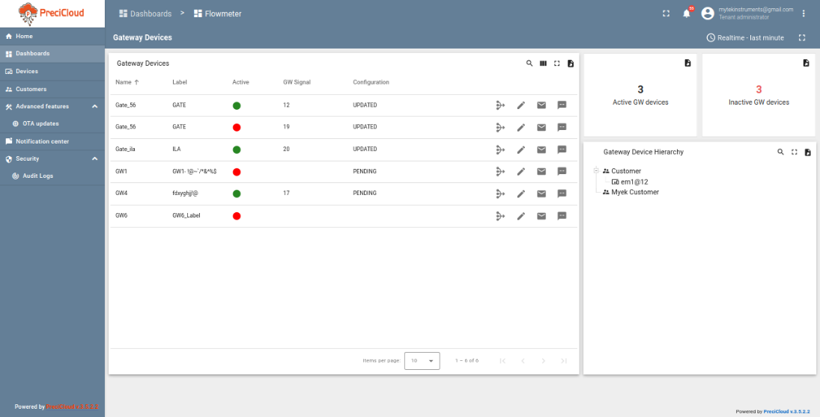

Figure 13 Flowmeter Dashboard

* + 1. Admin - Flowmeter Dashboard
* The flowmeter dashboard will show the following Widgets: Gateway devices, Active Gateway devices, Inactive Gateway devices, and Gateway Device Hierarchy.

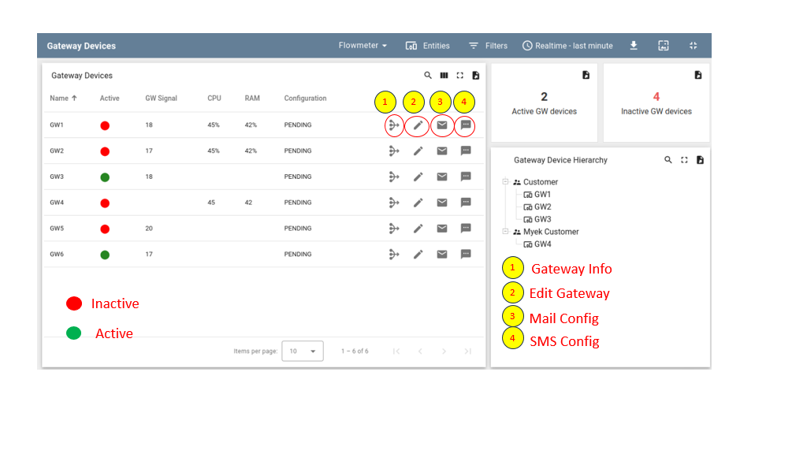

Figure 14 Flowmeter Dashboard

* Click the Active Gateway Device widget, and the dashboard will show the Active Dashboard widget.

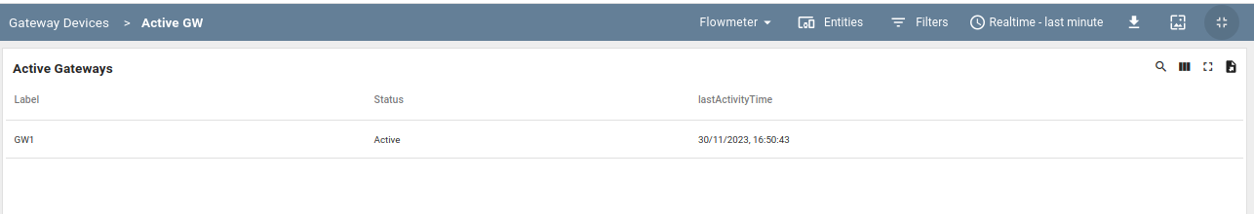

Figure 15 Active Gateway List

* Click the Inactive Gateway Device widget, and the dashboard will show the Inactive Dashboard widget.

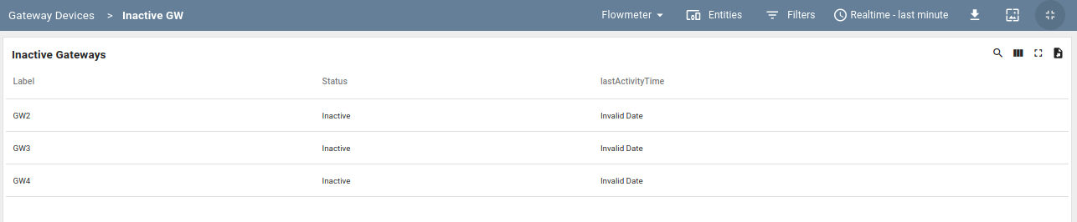

Figure 16 Inactive Gateway List

* 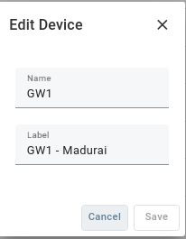On Gateway Device Row Click the Edit button, then the Edit Device popup will open, and the user can modify the Gateway label.

Figure 17 Edit Gateway Info

* Click the Gateway row, and then the dashboard will navigate to the selected Gateway device information state.

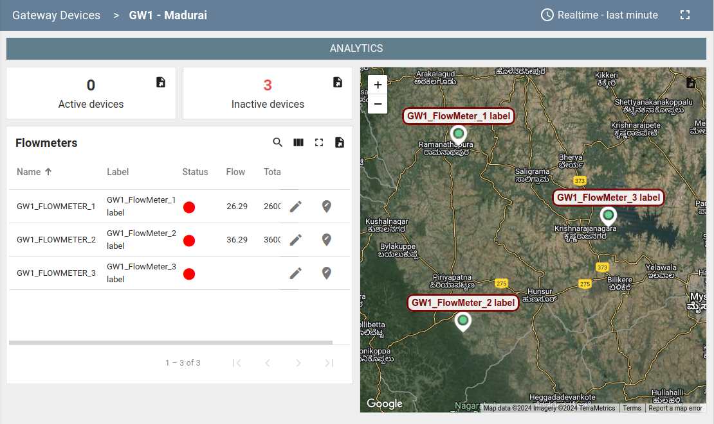

Figure 18 Gateway Device List

* Click the active device widget and the dashboard will show the active dashboard widget.

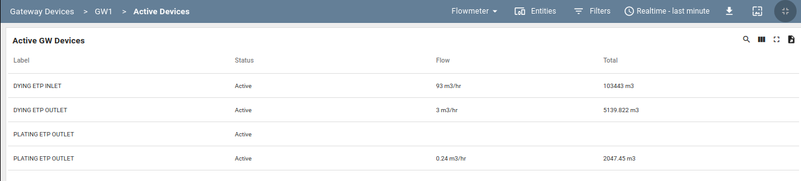

Figure 19 Active Devices

* + Click the inactive device widget and the dashboard will show the inactive dashboard widget.

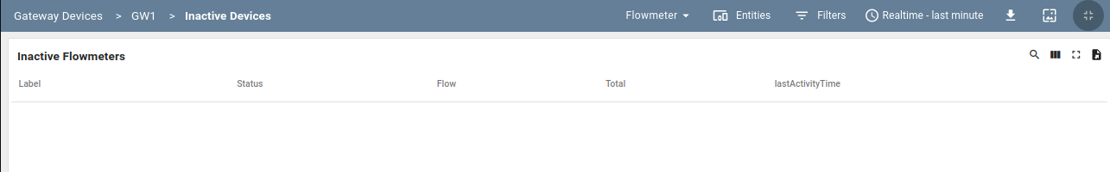

Figure 20 Inactive Devices

* + Click the Analytics button and click the flowmeter row to select the flowmeter, and then the dashboard will show the selected flowmeter consumption details.

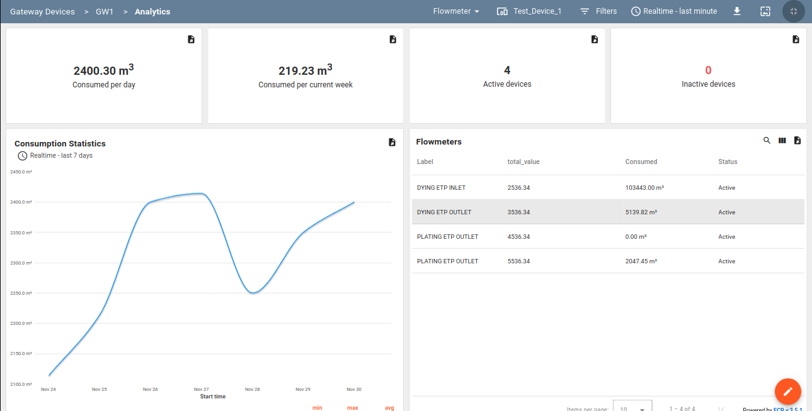

Figure 21 Consumption Details

* + Click “Edit” button to modify the Device Label

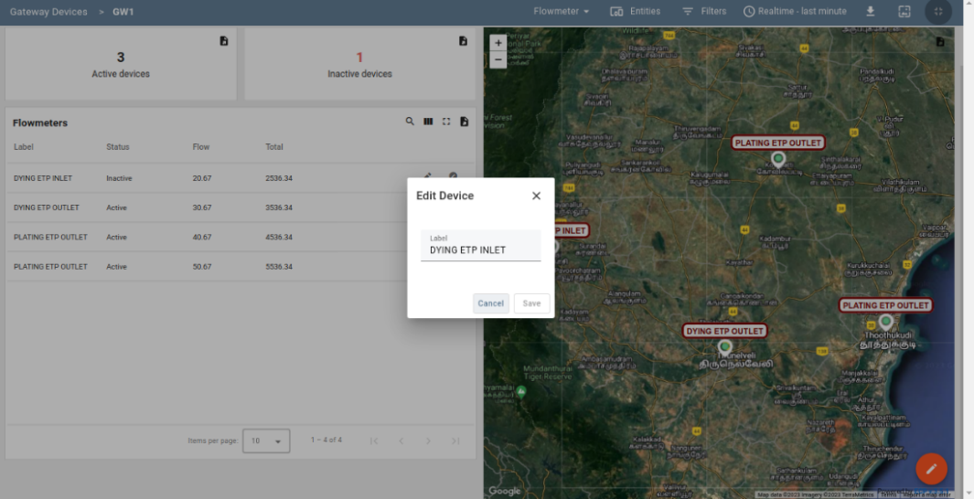

Figure 22 Edit Device Label

* + Click the “Location Edit” button to edit a device location.

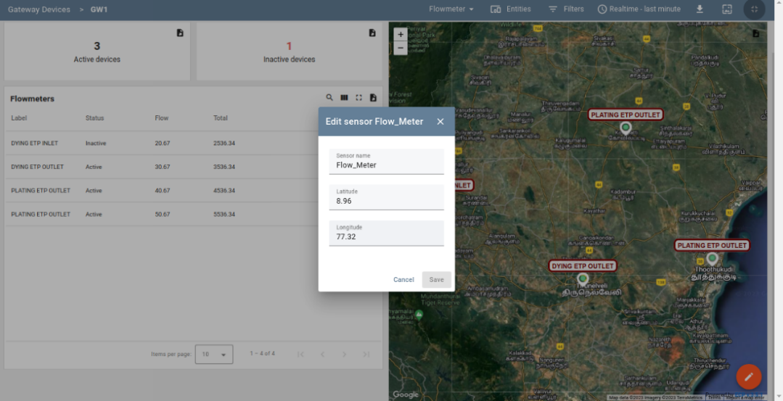

Figure 23 Edit Device Location

* Click the Flowmeter row, then the dashboard navigates to the flowmeter details state.

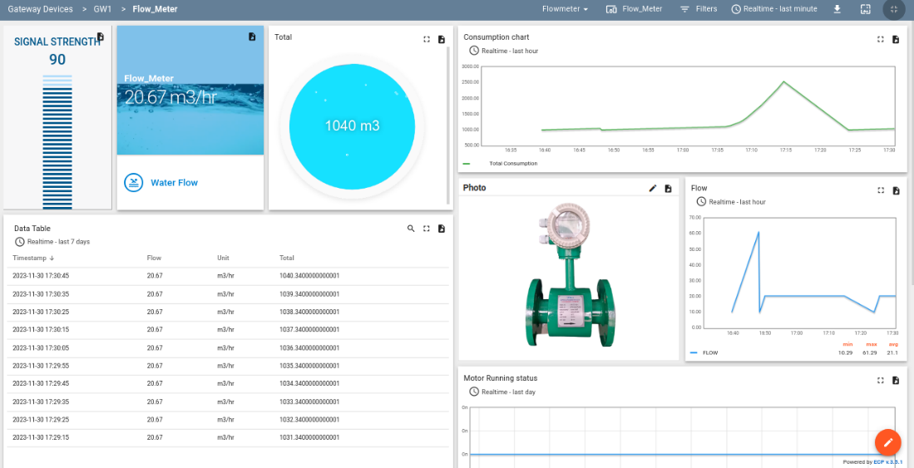

Figure 24 Flowmeter Info (i)

* Scrolling down the dashboard will show the additional information in Additional data widget. User can be able to add additional data columns.

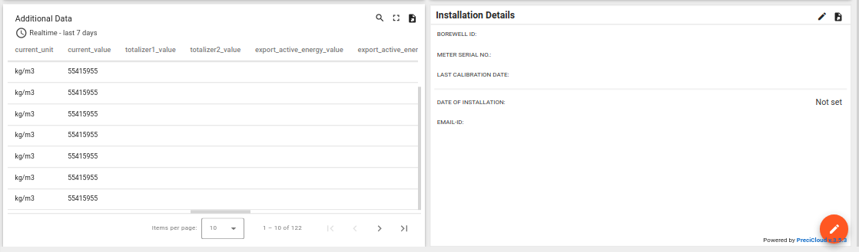

Figure 25 Flowmeter Info (ii)

* Click the “Edit” button at the bottom- right corner then click the Additional Data widget Edit button.

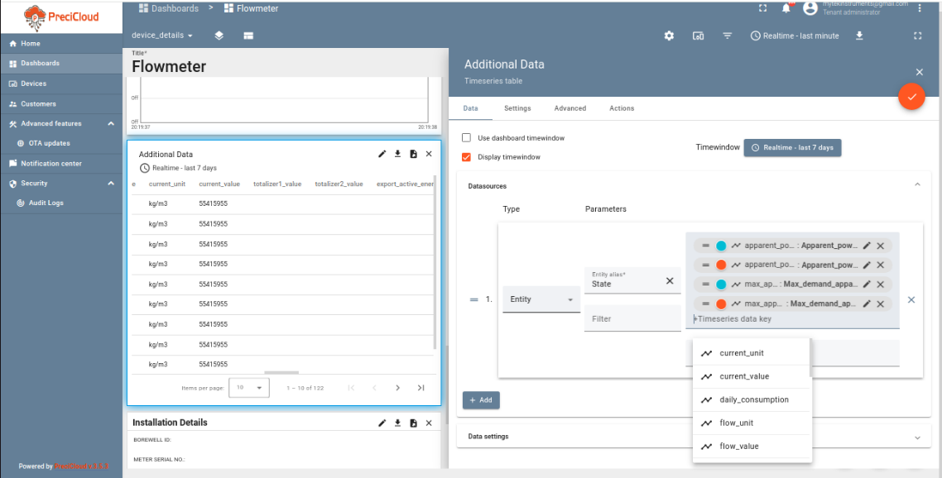

Figure 26 Edit Additional Info

* Select the data from the drop-down or enter new data and click “Save” button.
* Added information will be shown in the Additional Data widget.
  + - 1. Scheduler

In scheduler, each gateway has a separate mail configuration.

* Click the Mail Configuration Button in Gateway Row

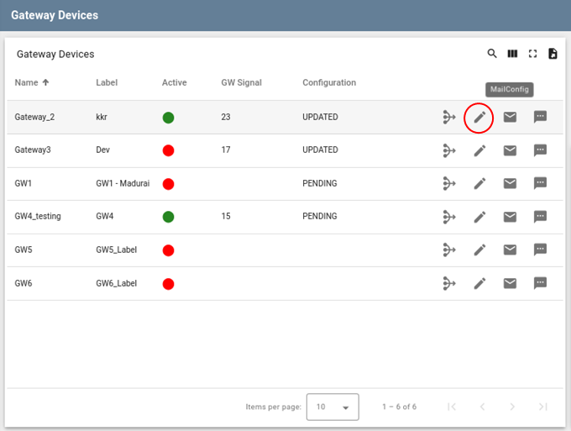

Figure 27 Mail Config

* In the Mail Scheduler pop-up window, click the “Add” button under the configuration option to continue,

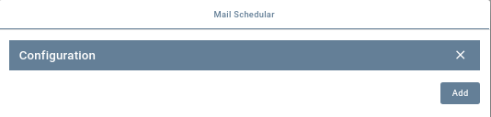

Figure 28 Mail Configuration Screen

* Click the Schedule row to configure the main information.

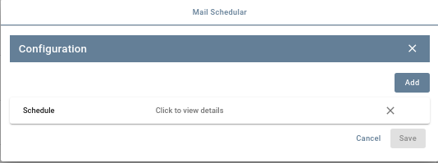

Figure 29 Mail Configuration

* Add the mail details and click the Save button.

*Note: Make the “Report Template” name as “FLOW_METER”*

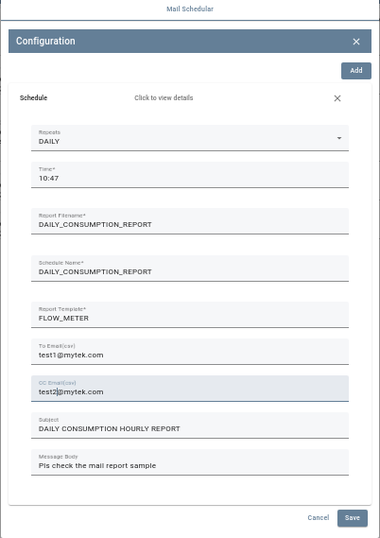

Figure 30 Mail Configuration Schedule tab

* Sample Mail Format for Daily Consumption report has been showed below,

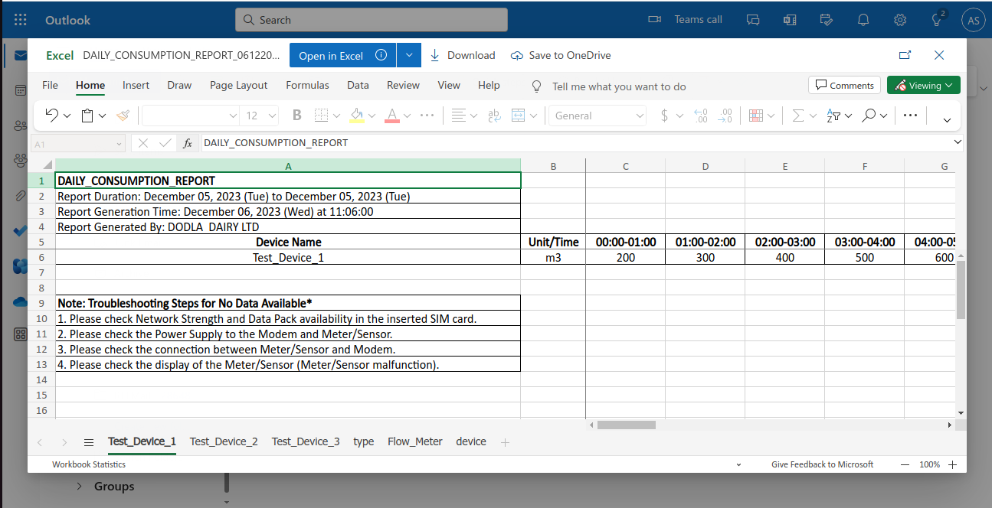

Figure 31 Sample Email Data

* + - 1. Gateway Info

In The Gateway Info state will show the gateway information, like configuration details and firmware details.

* In Dashboard row Click “GatewayInfo” button then the dashboard navigates to the Gateway Info State.

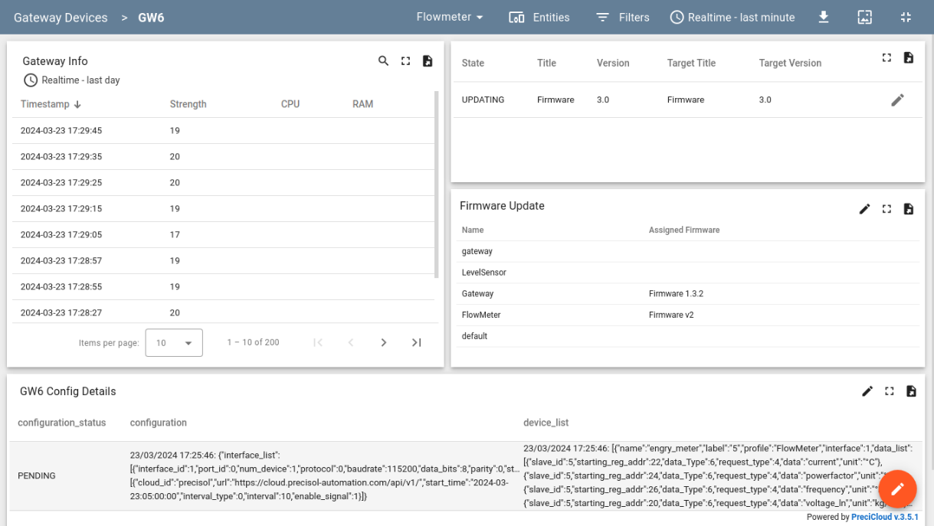

Figure 32 Gateway Info State

* The following Gateway Info widget will show the signal strength, CPU, and RAM.

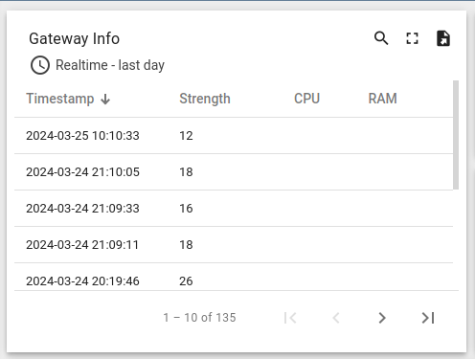

Figure 33 Gateway Info widget

* The following Gateway Firmware Info widget will show the Firmware Update State, current Firmware Title and Version and Target Firmware Title and Version.

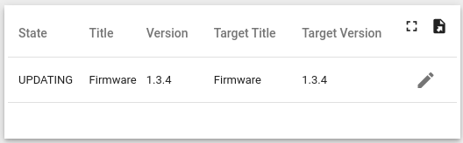

Figure 34 Firmware Info widget

* Click the “Edit” button user can update the gateway firmware

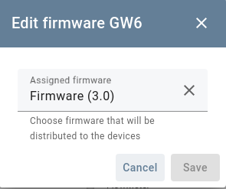

Figure 35 Edir Firmware Version

* The following Firmware Update widget will show the Device profile name with Assigned Firmware Title.

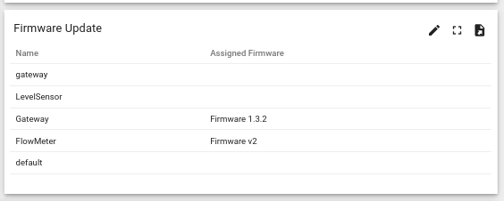

Figure 36 Device Profile with Assigned Firmware

* By clicking the Edit button, the user can update the profile firmware. In Device Profile Firmware Updating all gateways firmware will be updated

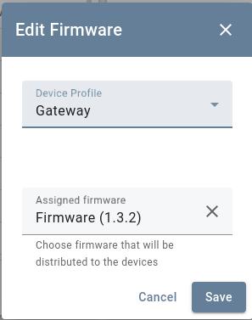

Figure 37 Update Firmware for Device Profile

* The following Gateway Configuration Widget will show the configuration and device list

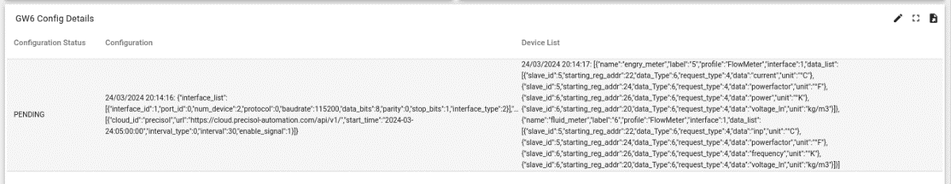

Figure 38 Gateway Configuration Details Widget

* Users can click the view button to view the Gateway/Device configuration.

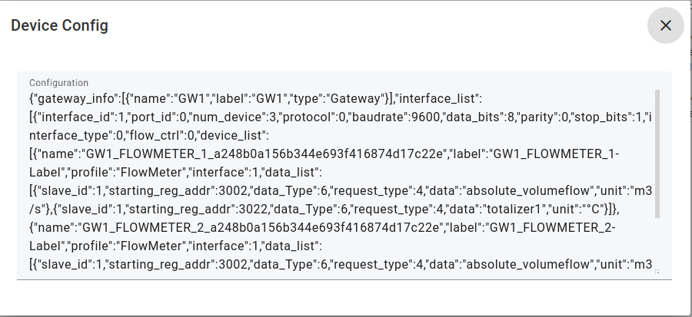

Figure 39 View Gateway Configuration

1. OTA UPDATES

PreciCloud allows users to upload and distribute over-the-air (OTA) updates to gateways. As a Tenant Admin, one can upload firmware to the OTA repository. Once uploaded, user may assign them to Device Profile or Device. PreciCloud will notify devices about the available update and provide a protocol-specific API to download the firmware. The PreciCloud tracks the status of the update and stores history of the updates. A user can monitor the update process using the dashboard. Successful firmware updating will show the status as “UPDATED”

* Navigate to the “OTA Updates” menu item to list and upload OTA update packages. Click “+” button to add new Package.

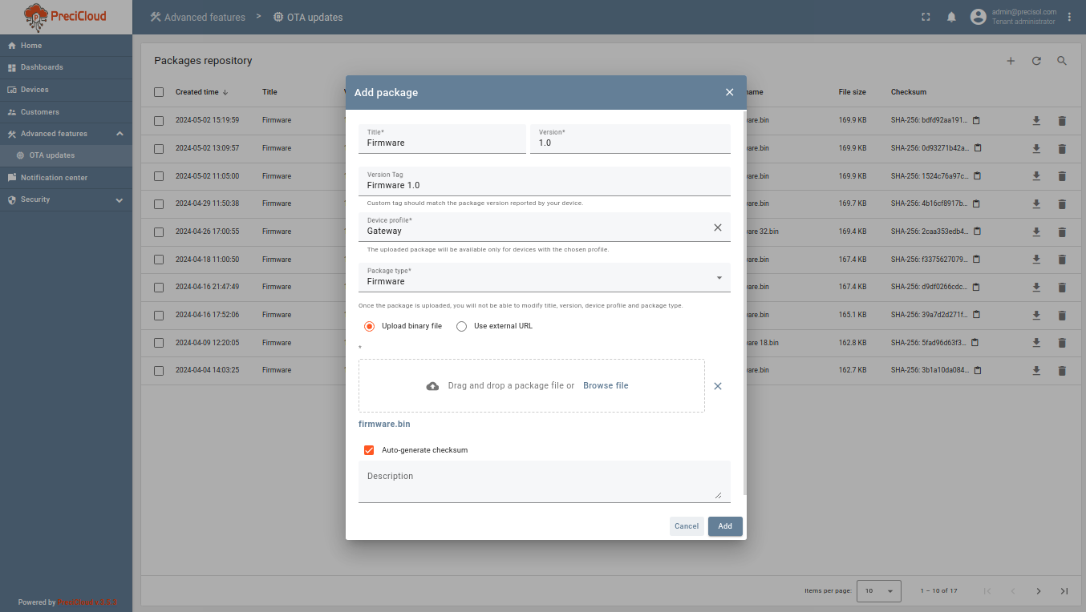

Figure 40 Add OTA Package

* Each package consist of:
* Title - the name of your package. You can use different names for production and debug firmware/software.
* Version - the version of your package. Combination of the title and version must be unique in scope of a tenant. Version pattern (x.y.z (or) x.yy.zz) must be less than seven characters
* Device Profile - each package is compatible with one device profile. We track compatibility to prevent accidental updates of devices with incompatible firmware/software. Link to a device profile means that device that use this profile may be updated to the current package. However, the update is not triggered, until the user or script [assigns](https://thingsboard.io/docs/user-guide/ota-updates/#assign-ota-package-to-device-profile) the package to the device profile or device.
* Type - can be Firmware.
* Checksum algorithm - (optional), it is a short name of the checksum algorithm to use.
* Checksum - (optional) the value of the file checksum. eSHA-256 algorithm automatically.
* Description - optional text description of the firmware.
* Navigate to dashboard and Open Firmware Dashboard. Gateway devices are listed with Firmware details in the Devices table.

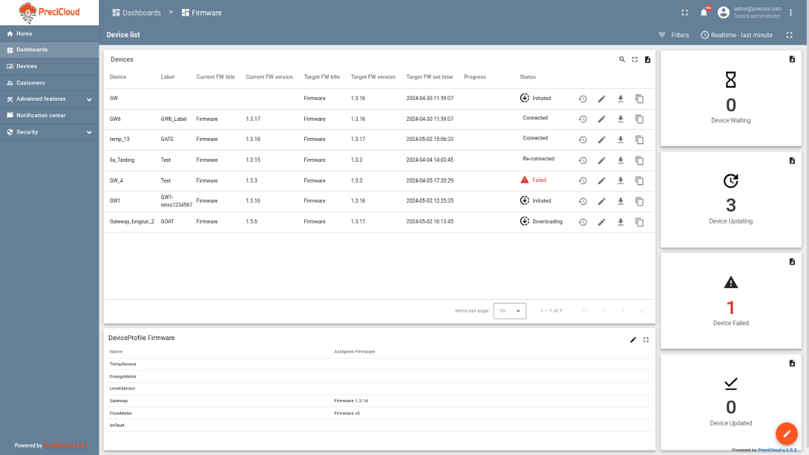

Figure 41 Firmware Dashboard

* 1. Assign OTA Package to Device
* You may also assign firmware to specific device.
* Click the Edit button in the Devices table to edit firmware information.

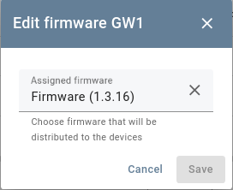

Figure 42 Edit Gateway Firmware

* From the drop-down menu select firmware that you would like to assign to this device.
* After selecting firmware, click “Save” button
* The firmware version assigned to the device will automatically overwrite the firmware version that is assigned to the device profile.
  1. Assign OTA Package to Device Profile
* Users can assign firmware to the device profile to automatically distribute the package to all devices that share the same profile.
* Device profile Firmware table click edit button to edit firmware information.

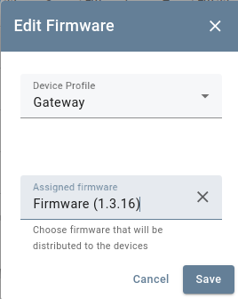

Figure 43 Edit Device Profile Firmware

* From the 1st drop-down menu select Device Profile and 2nd drop-down menu select firmware to assign to this device profile.
* After selecting, click “Save” button
* The device profile details will let you to choose only compatible OTA update packages. Device profile may be used by thousands of devices.
* Assignment of the firmware/software triggers the OTA update process.

1. CUSTOMER

A customer user belongs to the customer and has read permissions to view dashboards assigned by the tenant Admin.

* 1. Login Screen
* Enter the Customer credentials and click login

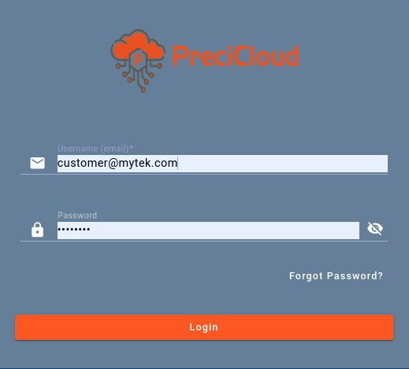

Figure 44 Customer Login Screen

* 1. Home
* After a successful login, the customer's home screen will show the assigned dashboard. In the below screenshot, the flowmeter dashboard is shown for reference.

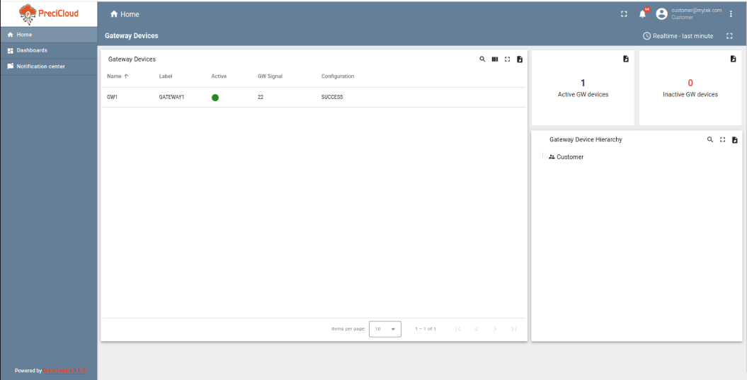

Figure 45 Customer Home Page

* Click the Gateway row, and then the dashboard will navigate to the selected Gateway device information state.

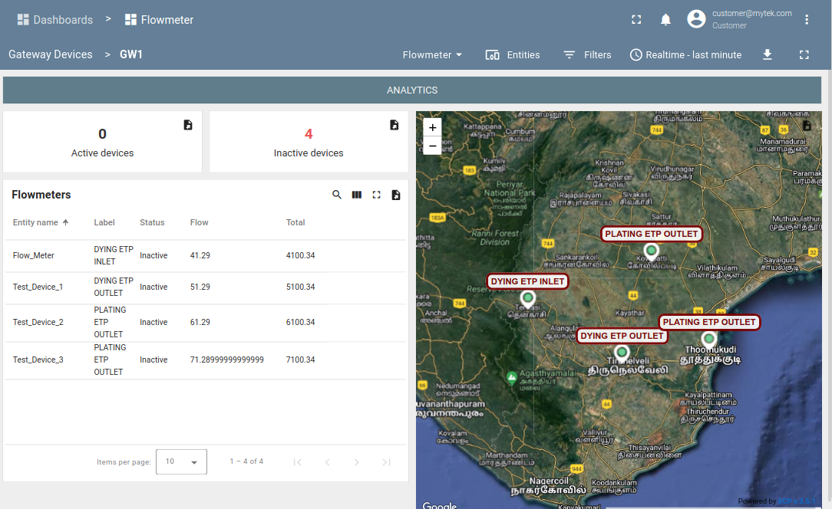

Figure 46 Gateway Device List

* Click the Flowmeter row, then the dashboard navigates to the flowmeter details state.

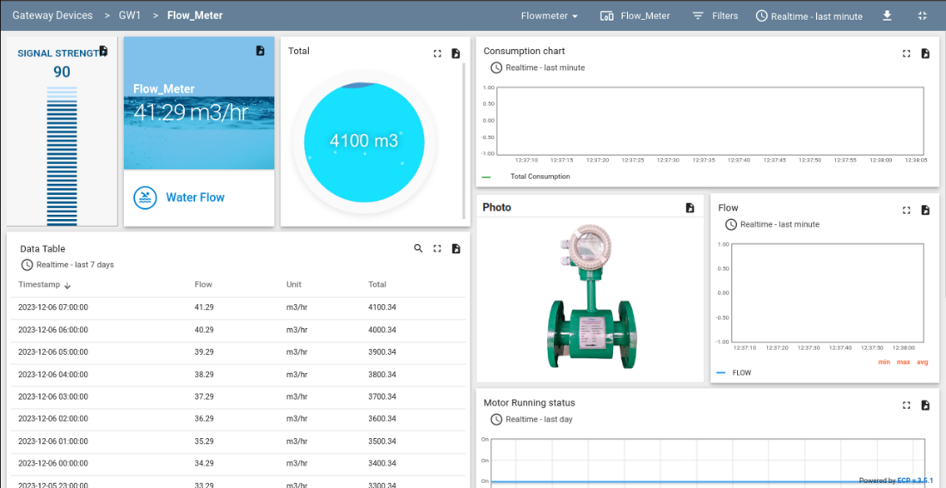

Figure 47 Flowmeter Info

* Click the Analytics button and click the flowmeter row to select the flowmeter, and then the dashboard will show the selected flowmeter consumption details.

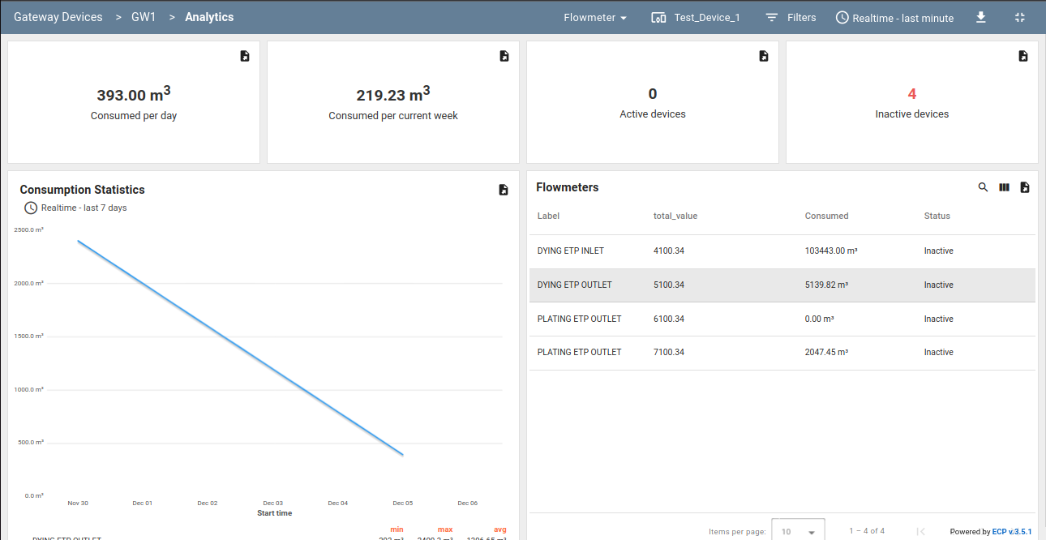

Figure 48 Consumption Details

* 1. Dashboards
* The Dashboards screen will show the assigned dashboard from the Tenant Admin. The sample dashboard screen (Flowmeter Dashboard) of a customer has been captured below for reference.

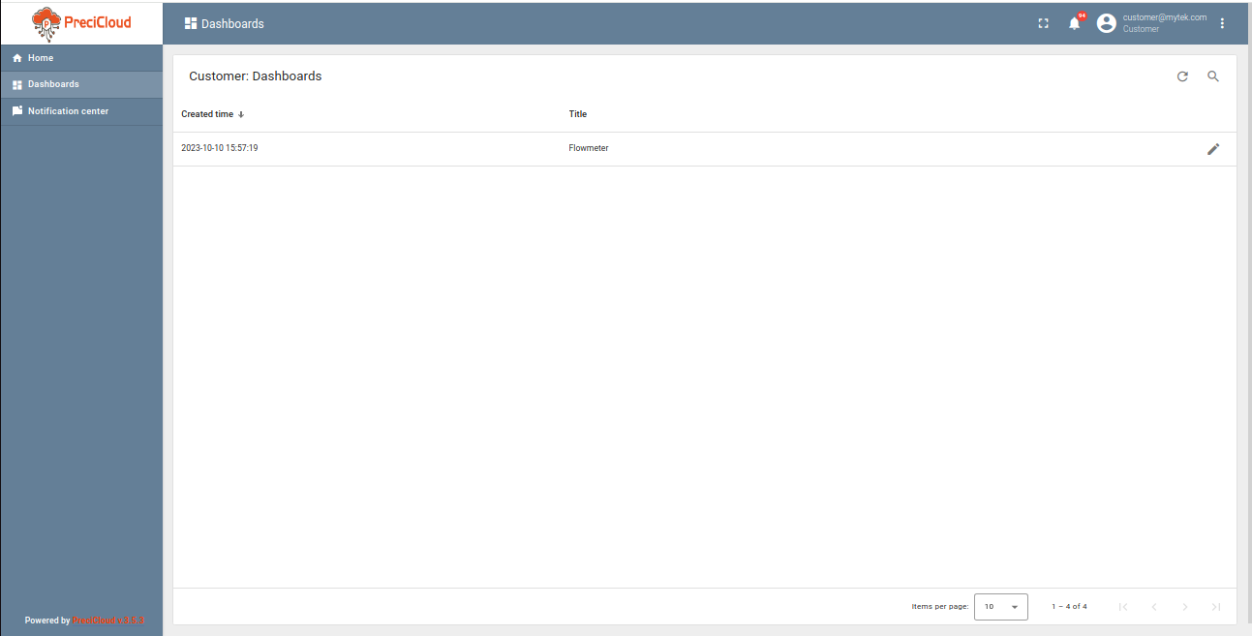

Figure 49 Customer Dashboards

* 1. Notification Center
* The notification center tab which is placed in the left side of the application window (Just below “Home’ tab) will show events like device creation, device active/inactive, and device alarms.

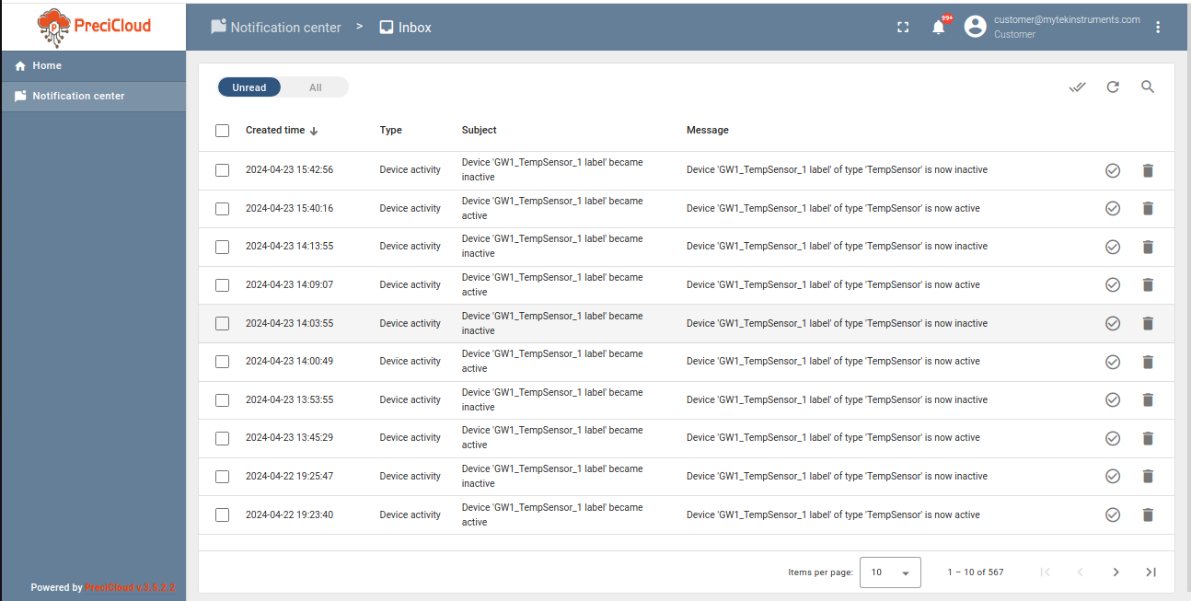

Figure 50 Notification Screen

1. USERS PROFILE

Users can able to change their profile information and password using the options available in the PreciCloud Application (3-Dots in the right- top corner)

* User needs to click “More” options (3-Dots in the right- top corner) which is available in the application to update the profile information and for password modifications.

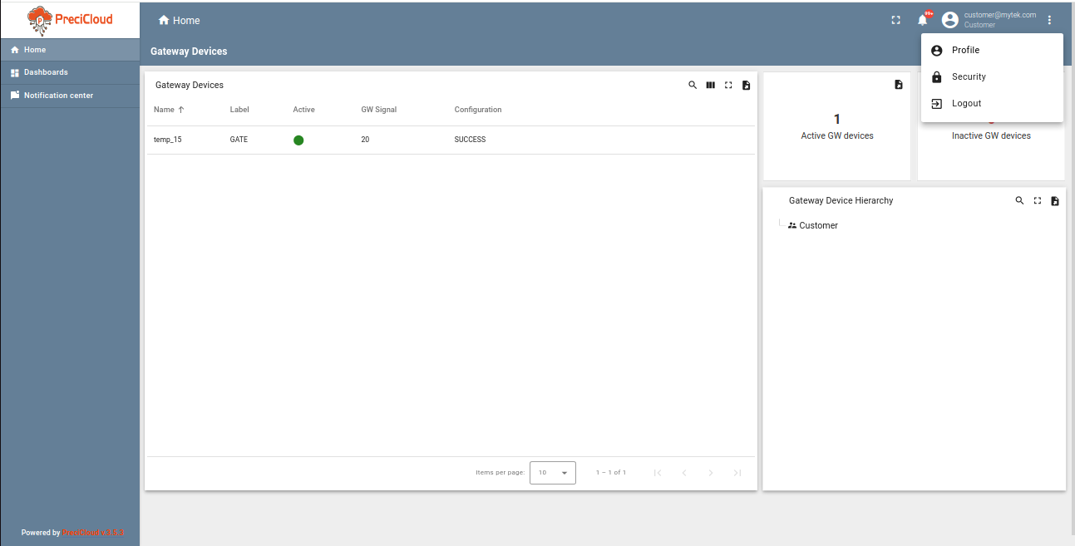

Figure 51 User Account

* 1. Profile Screen
* Users can update their information like Name, Email, Mobile number, Language and etc., in the profile screen.
* Below image shows the options available in the “Profile” screen added with the sample data for reference.

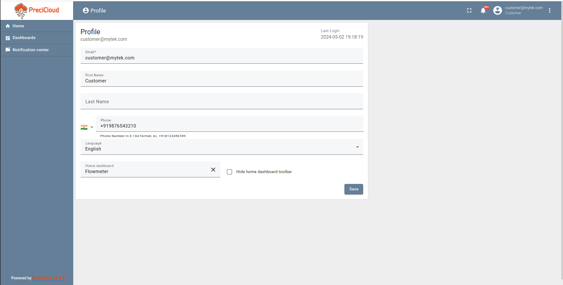

Figure 52 User Profile Screen

* 1. Security Screen
* User can change/update their password using the “Security” option
* To update/change the password user needs to provide the older password followed with new password

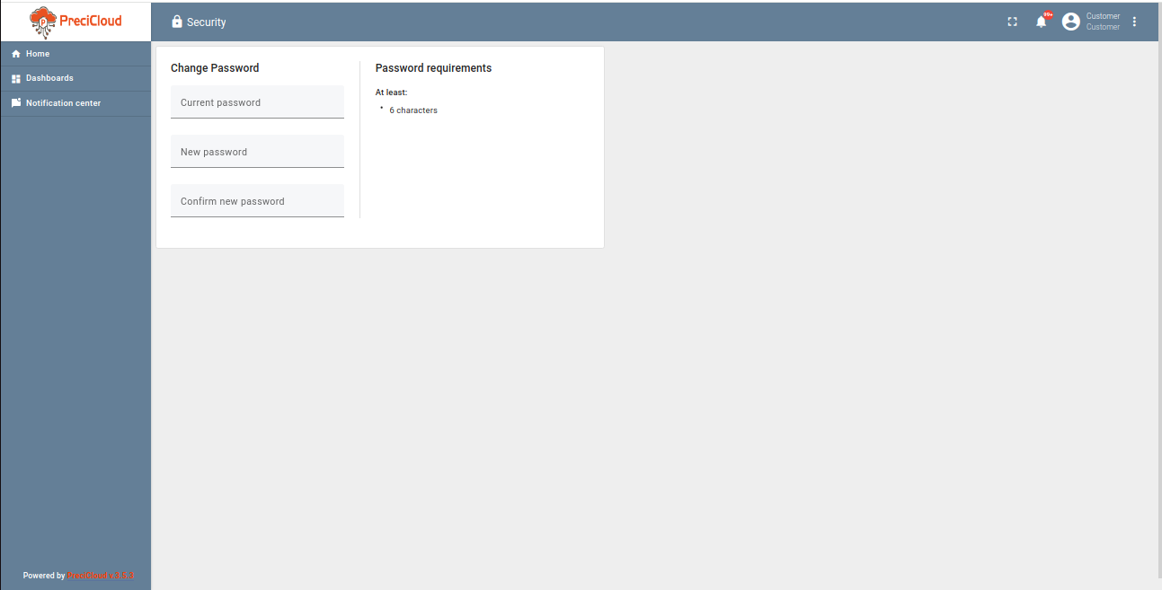

Figure 53 User Security Screen

* 1. Logout
* Users can logout using this available Logout button. After the Logout, The current page will be navigate to login screen.

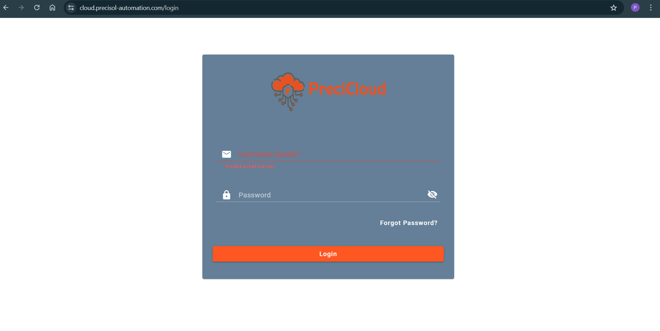

Figure 54 Welcome Screen after Logout

1. LIMITATIONS

* The device name must be unique for a single gateway and should be a maximum of 20 characters, consisting of alphabets, numbers, and underscores.
* The device label should be a maximum of 16 characters. Backslashes (\) and quotation marks (“) are not allowed in the label.
* The device's status, which can be either active or inactive, changes based on the time intervals specified in the gateway configuration. By default, if the device does not send any data for 10 minutes, its status will be set to inactive. The device's status will be considered active as long as it sends data at regular intervals. If the cloud does not receive any data from the device within the specified timeout intervals, the cloud will update the device status to inactive.